**University Rover Challenge: Tutorials and Team Survey**

**Daniel Snider, Matthew Mirvish, Michał Barciś, Vatan Aksoy Tezer**

**Abstract** In this tutorial chapter we present a guide to building a robot through 12 tutorials. We prescribe simple software solutions to build a wheeled robot and manipulator arm that can autonomously drive and be remotely controlled. These tutorials are what worked from several teams at the University Rover Challenge 2017 (URC). The tutorials provide a quick start guide to using existing Robot Operating System (ROS) tools, others are new contributions, or explain challenging topics such as wireless communication and robot administration. We also present the results of an original survey of 8 competing teams to gather information about trends in URC’s community which consists of hundreds of university students on over 80 teams. Additional topics include satellite mapping of robot location (mapviz), GPS integration (original code) to autonomous navigation (move_base), and more. We hope to promote collaboration and code reuse.

**Keywords**  Outdoor robot · Arm control · Autonomous navigation · Teleoperation · Panoramas · Image Overlay · Wireless · GPS · Robot administration

Contents

1 Introduction 1

1.1 Motivation 1

1.2 Main Objectives 1

1.3 Overview of Chapter 1

2 Background 1

2.1 About the University Rover Challenge 1

2.2 Prerequisite Skills for Tutorials 1

3 Survey of URC Competing Teams 1

3.1 Highlighted Rover Team Experiences 1

4 ROS Environment 1

4.1 ROS Software Architecture in Team R3’s Rover 1

5 Tutorials 1

5.1 Tutorial: Autonomous Waypoint Following 1

5.2 Tutorial: Image Overlay Scale and Compass 1

5.3 Tutorial: A Simple Drive Software Stack 1

5.4 Tutorial: Velocity Controlled Arm 1

5.5 Tutorial: Autonomous Recovery after Lost Communications 1

5.6 Tutorial: Stitch Panoramas with Hugin 1

5.7 Tutorial: GPS Navigation Goal 1

5.8 Tutorial: Wireless Communication 1

5.9 Tutorial: Autonomous Navigation by Team ITU 1

5.10 Tutorial: Autonomous Navigation by Team R3 1

5.11 Tutorial: MapViz Robot Visualization Tool 1

5.12 Tutorial: Effective Robot Administration 1

6 Conclusion 1

# Introduction

The University Rover Challenge (URC) is an extremely difficult design competition held in the Utah desert that requires large teams of sometimes 50 or more university students to spend long hours for a year working on engineering a teleoperated and autonomous rover and articulated arm from scratch. Our mission is to give readers an overview of eight rover designs used at the URC, as well as a deep dive into three designs. We detail how to build a rover by piecing together existing code, lowering the challenges for new Robot Operating System (ROS) users. The contributions of our book chapter include 12 tutorials, 7 new ROS packages, and an original survey of 8 teams after they participated in the URC 2017 rover competition.

## Motivation

At URC there is a rule[1] limiting the budget that is allowed to be spent by teams on their rover to $15,000 USD. Therefore students typically engineer parts and software themselves rather than buying. This makes ROS’s free and open source ecosystem a natural fit for teams to cut costs and avoid reengineering common robotics software. At URC 2017, Team R3 spoke to several teams who are not using ROS but want to, and others who want to expand their use of it.

Several authors of this chapter joined URC because they are passionate about hands on learning and ROS. After our URC experience we are even more confident that ROS is an incredible tool for building advanced robotics quickly with strong tooling that makes administering ROS robots enjoyable.

We are motivated by our passion to share what we learned and built so that others can meet and exceed our abilities. Software is eating the world and there is a large positive impact that can be made in the application of software interacting with the physical world. We share our software freely so it can have the largest unencumbered impact and usefulness.

## Main Objectives

Above all we aim to help ROS users quickly learn new capabilities and as a result the bulk of our contributions are in the tutorials of section 5. We hope to make the tutorials more relevant and interesting by giving them in context of the URC competition (throughout the chapter). We also think that readers be able to better assess the usefulness of our tutorials by comparing them to the other approaches that our survey of eight other teams have revealed in section 3. The team survey results acts as overview and the 12 tutorials act as a deep drive into the technical implementations of 3 teams: Team R3 from Ryerson University in Toronto, Canada, and Team Continuum from the University of in Wroclaw, Poland, and the ITU Rover Team from Istanbul Technical University in Turkey. Original ROS packages are documented with examples, installation and usage instructions, and implementation details. At the end of the chapter readers should have a better sense of what goes into building a rover and of the challenges of the URC.

## Overview of Chapter

Section 2 “Background” provides an explanation of the URC rover competition and some of its rules.

Section 3 “Survey of URC Competing Teams” presents the results of an original survey of 8 teams who competed at URC 2018. It details each team’s rover computer setup, ROS packages, control software, and avionics hardware for communication, navigation, and monitoring.

Section 4 “ROS Environment” gives a case-study of the ROS software architecture used in Team R3’s Rover. It provides the basis for some of the tutorials in section 5 to dive into more detailed explanations.

Section 5.1 “Tutorial: Autonomous Waypoint Following” details the usage of a new, original ROS package that will queue multiple move_base navigation goals and navigate to them in sequence. This helps URC teams in the autonomous terrain traversal missions.

Section 5.2 “Tutorial: Image Overlay Scale and Compass” details a new, original ROS package that meets one of the URC requirements to overlay an image of a compass and scale bar on imagery produced by the rover. It is intended to add context of the world around the rover.

Section 5.3 “Tutorial: A Simple Drive Software Stack” details the usage and technical design of a new, original ROS package that will drive PWM motors given input from a joystick in a fashion known as skid steering. The new package contains Arduino firmware and controls a panning servo so that a teleoperator can look around with a camera while driving.

Section 5.4 “Tutorial: Velocity Controlled Arm” details the usage and technical design of a new, original ROS package that will velocity control arm joint motors, a gripper, and camera panning. The new package contains Arduino firmware to control PWM motors and a servo for the camera.

Section 5.5 “Tutorial: Autonomous Recovery after Lost Communications” details the technical design and usage of a new, original ROS package that uses ping to determine if the robot has lost connection to a remote base station. If the connection is lost then motors will be stopped or an autonomous navigation goal will be issued so to reach a configurable location.

Section 5.6 “Tutorial: Stitch Panoramas with Hugin” details the usage and technical design of a new, original ROS package that will create panoramic images using ROS topics. At the URC competition teams must document locations of interest such as geological sites with panoramas.

Section 5.7 “Tutorial: GPS Navigation Goal” details the usage and technical design of a new, original ROS package that will convert navigation goals given in latitude and longitude GPS coordinates to ROS frame coordinates.

Section 5.8 “Tutorial: Wireless Communication” gives a detailed explanation of the primary and backup wireless communication setup used between ITU Rover Team’s rover and base station for up to 1 km in range.

Section 5.9 “Tutorial: Autonomous Navigation by Team ITU” documents the autonomous system used by Istanbul Technical University’s rover team. Their approach consists of twist_mux and move_base ROS packages, and their own OpenCV C++ implementation for finding tennis balls. The tennis balls are the objectives of the URC autonomous traversal mission.

Section 5.10 “Tutorial: Autonomous Navigation by Team R3” explains the technical architecture of the autonomous system used at URC 2017 by Team R3 from Ryerson University, Toronto. It is based on the ZED stereo camera, the rtabmap ROS package for simultaneous localization and mapping (SLAM), and the move_base navigation ROS package.

Section 5.11 “Tutorial: MapViz Robot Visualization Tool” presents the MapViz ROS package and illustrates how a top-down, 2D visualization tool with support for satellite imagery can be useful for outdoor mobile robotics and URC. We also document the Docker container that we created to easy the use of MapViz with satellite imagery.

Section 5.12 “Tutorial: Effective Robot Administration” discusses a helpful pattern for robot administration that makes use of tmux and tmuxinator to roslaunch many ROS components in separate organized terminal windows. This makes debugging and restarting individual ROS components easier.

Section 6 “Conclusion” ends with the main findings of the chapter and with ideas for further collaboration between URC teams and beyond.

# Background

## About the University Rover Challenge

The University Rover Challenge is an international robotics competition run annually by The Mars Society. Rovers are built for a simulated Mars environment with challenging missions filling three days of competition. It is held in the summer time at the very hot Mars Desert Research Station, in Utah. There were 35 rovers and more than 500 students from seven countries that competed in the 2017 competition[2]. The winning team’s rover can be seen in Fig. 1.

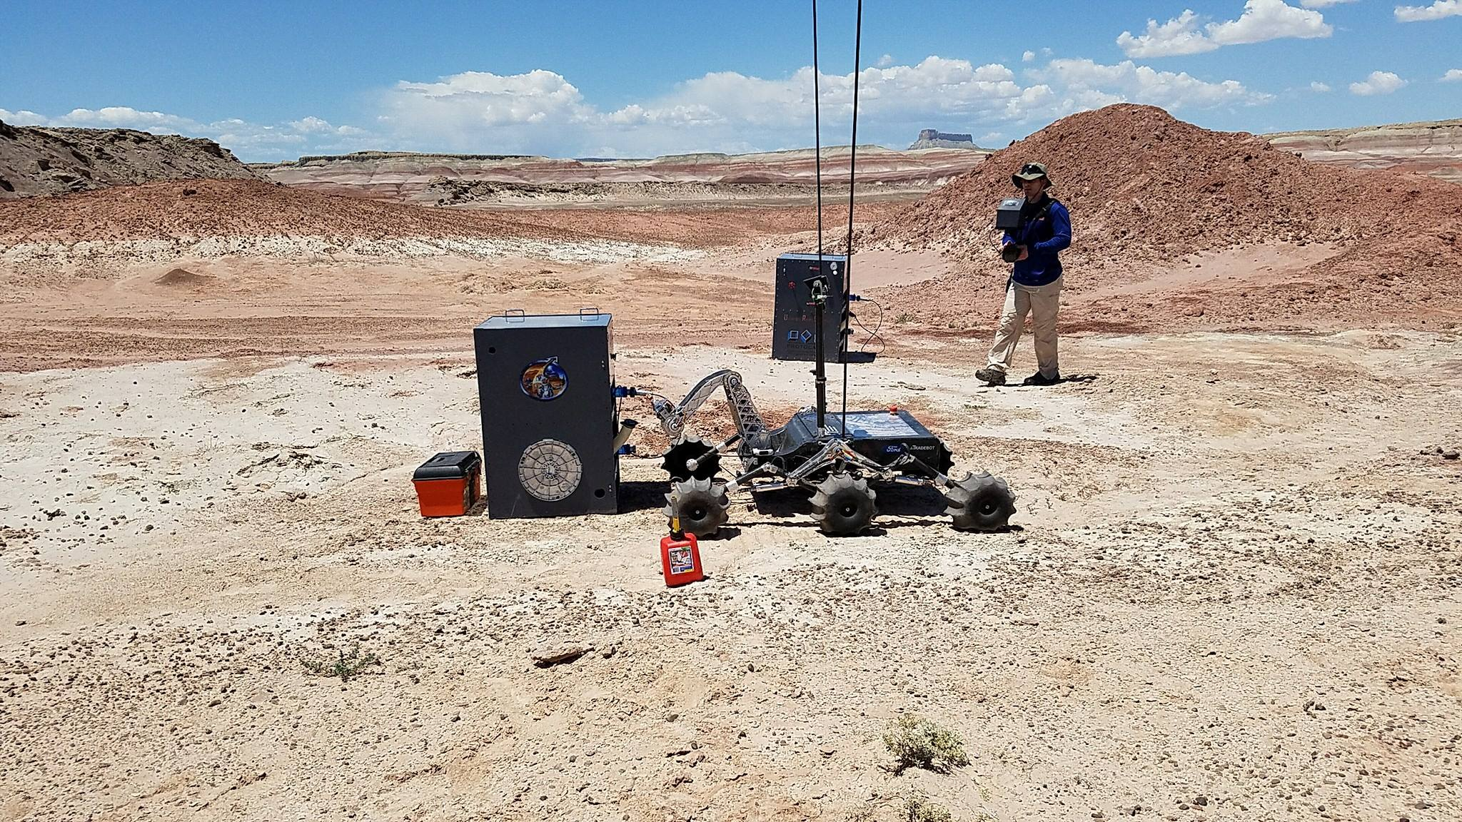

**Fig. 1** A URC competition judge watches as the winning team of 2017, Missouri University of Science and Technology, completes the Equipment Servicing Task.

Rovers must be operated remotely by team members who cannot see the rover or communicate with people in the field, such actions are punished by penalty points. Teams must bring and setup their own base station in a provided trailer or shelter and a tall communication mast nearby for wireless communication to the rover. The rover may have to travel up to 1km and even leave direct line of sight to the wireless communication mast.

The idea is that the rover is on Mars (the Utah desert serves as a substitute) performing scientific experiments and maintenance to a Mars base. An assumption is made that the rovers are being operated by astronauts on or orbiting Mars rather than on Earth and therefore there is no major communication delay.

#### University Rover Challenge Tasks

The URC rules[3] detail four tasks that we summarize here. The science cache task involves retrieving and testing subsurface soil samples without contamination. For this the rover is required to have an auger to drill into the desert soil. After the science task teams present to a panel of judges about their scientific findings. The evidence collected by the rovers cameras, soil collection, and minimum three 3 sensors (eg. temperature, humidity, pH) is presented in a way that purports the possibility of water and life on Mars.

The extreme retrieval and delivery task requires teams to search out tools and marked rocks in the desert and then use an arm on the rover to bring them back to the base station. The equipment servicing task has teams perform finer manipulations with their rover arm to start a fake generator. This consists of pouring a fuel canister, pressing a button, flicking a switch and much more.

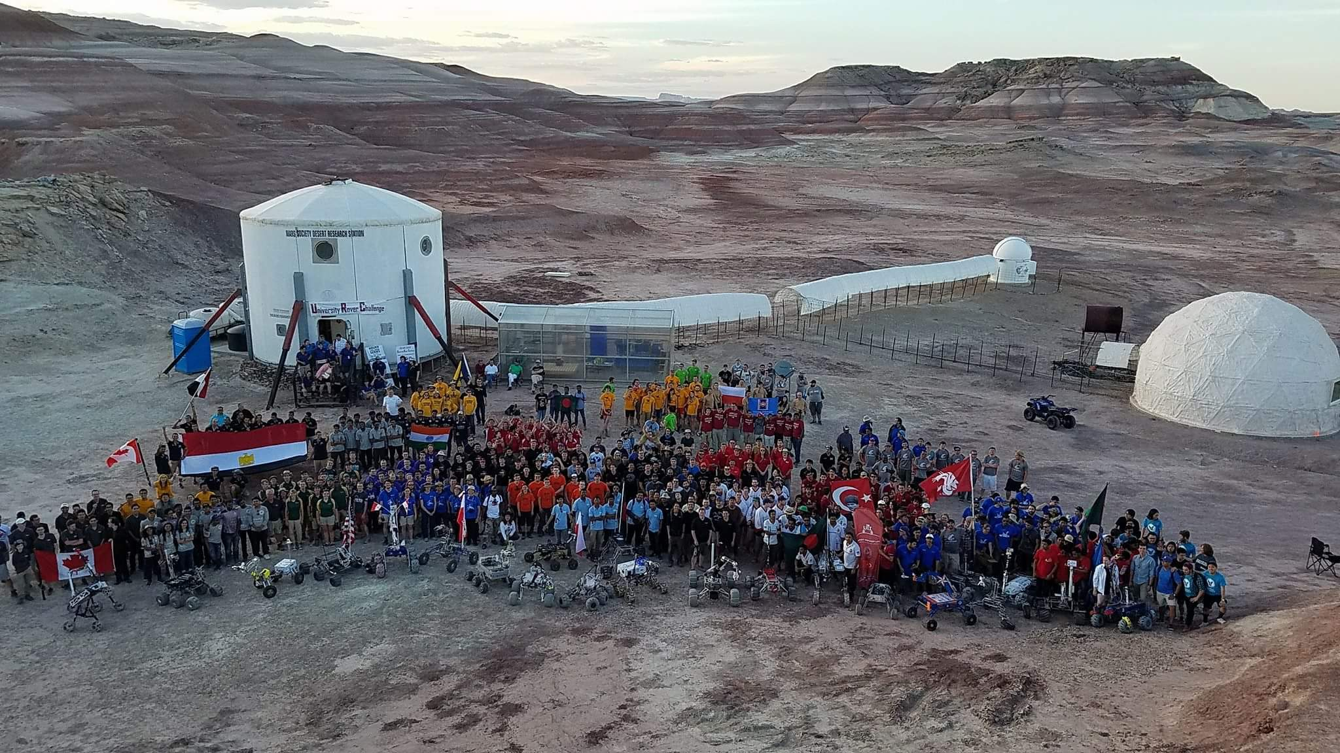

**Fig. 2** Group photo of URC 2017 finalists at the Mars Desert Research Station in Utah.

In the autonomous task teams must start with their rover within 2 m of the designated start gate and must autonomously navigate to the finish gate, within 3 m. Teams are provided with GPS coordinates for each gate and the gates are marked with a tennis ball elevated 10 – 50 cm off the ground and are not typically observable from a long distance. Teams may conduct teleoperated excursions to preview the course but this will use their time. Total time for this task is 75 minutes per team and the total distance of all stages will not exceed 1000 m.

Teams must formally announce to judges when they are entering autonomous mode and not transmit any commands that would be considered teleoperation, although they can monitor video and telemetry information sent from the rover. On-board systems are required to decide when the rover has reached the finish gate.

The newer 2018 rules[4] are very similar, but with more difficult manipulation tasks such as typing on a keyboard and a more demanding autonomous traversal challenge that explicitly calls for obstacle avoidance–something that Team R3 had last year and is explained in detail in section 5.9.

file

## Prerequisite Skills for Tutorials

The tutorials in this chapter expect the following skills at a basic level, though they are useful to continue learning about.

* ROS basics (such as roslaunch)
* Command line basics (such as bash)
* Ubuntu basics (such as apt package manager)

# Survey of URC Competing Teams

The following teams were surveyed to ask about their rover computer setup, ROS packages, control software, and avionics hardware (for communication, navigation, and monitoring). The team survey results have been edited and condensed for publication.

This survey serves the purpose of providing a broad overview of components and rover development styles before diving into a few detailed implementations in subsequent sections provided by the teams who authored this chapter: Team R3, Team Continuum, and ITU Rover Team.

Several trends that emerged from the survey are interesting to note. Of the 8 teams surveyed, teams that used Raspberry Pis or STM microcontrollers all placed better than teams that used Arduinos or Teensy microcontrollers. For teleoperator input, Logitech controllers or joysticks were extremely popular and used by all teams. Teams most often expressed difficulty using IMUs or not testing their rover enough. A wide variety of autonomous systems were experimented with: from custom OpenCV implementations, to using existing vision-based obstacle avoidance software (rtabmap), to GPS only approaches.

The winning approach of the Mars Rover Design Team from Missouri University of Science and Technology utilized a large number of custom solutions. Their high quality solutions and extremely comprehensive testing is exemplified in just one case by developing a custom UDP communication software. Dubbed “RoveComm”, their communication system can reduce latency and increase video quality and is key to successful teleoperation.

|  |  |  |  |  |  |  |  |  |
| --- | --- | --- | --- | --- | --- | --- | --- | --- |
|  | Mars Rover Design Team | Team Continuum | Cornell Mars Rover | ITU Rover Team | UWRT Robotics Team | Ryerson Rams Robotics (R3) | SJSU Robotics | Team Anveshak |
| School Name | Missouri University of Science and Technology | University of Wroclaw, Poland | Cornell University, USA | Istanbul Technical University, Turkey | University of Waterloo, Canada | Ryerson University, Canada | San Jose State University, USA | Indian Institute of Technology, Madras |
| Final Score (Rank) | 403.4 **(1)** | 336.3 (2) | 264.1 (11) | 243.1 (13) | 225.7 (15) | 190.9 (21) | 164.3 (26) | 151.4 (29) |
| Computers on roverH:\Dropbox\Dropbox\ROSBook\old\FontAwesome\hdd-o.png | Raspberry Pi, TIVA-C Connected, MSP-432, Launchpad-C2000 | A Banana Pi,  3x Raspberry Pi, 1x Jetson (optionally), multiple STM microcontrollers | A Intel NUC N82E16856102053, and 8x PIC32 MX530F128H microcontrollers | A Raspberry Pi 3 with 64gb SD card running Ubuntu 16.04, STM32F103 microcontrollers | A FitPC miniature fanless PC | A Jetson TX1 with 32 GB SD card, Ubuntu 16.04, and 2x  Arduino Mega microcontrollers | Odroid XU4,  and Teensy 3.2 microcontroller | A Thinkpad T460 laptop running Ubuntu 14.04, and Arduino microcontrollers |
| Joysticks Captionless Image | Xbox Controller, Logitech Extreme 3D Pro | Logitech Gamepads | Logitech Gamepad F310, Thrustmaster VG T16000M FCS Joystick | 2x Logitech Extreme 3D Pro, one for driving and one for the arm | 2x Logitech joysticks for the arm, and an Xbox controller for driving | Xbox 360 Controller for drive, Logitech Extreme 3D Pro for arm | Logitech Extreme 3D Pro Joystick | 2x Logitech F310 Gamepads, one for telemetry control and one for auger/arm |
| Cameras Captionless Image | Lorex, Sony EFFIO CCD Superhead | Standard Raspberry Pi  cameras and two with wide angle lenses | Logitech HD Laptop Webcam C615, x264 video encoding | 5 IP cameras used for security and an Xbox 360 Kinect v1 for image processing and fake laser | 2x Pointgrey cameras, 1x USB Camera | ZED depth camera,  2x BL170 degree fisheye cameras | CCD 700TVL Composite video cameras (RunCam Swift 2.0) | SJ-CAM, IP-Camera, and a Logitech webcam. Cameras were interfaced using the "motion" Linux package, though it lags and quality was not great |
| Captionless Image  GPS | MTK 3339 | Ublox GPS | USGlobalsat BU-353-S4 | Radiolink M8N | Microstrain | Linx FM Series GPS Receiver | UBlox GPS 7 | ROS All Sensors Android App |
| IMU  Captionless Image | LSM9DS1 | Tried multiple units, nothing really worked | SparkFun SEN-13762, chip: MPU-9250 | GY-80 | Microstrain | MPU-9250 module, couldn’t get it working | BNO055 | ROS All Sensors Android App on Moto Play G4 phone |
| Software Packages  Captionless Image | Energia, TI motorware, OpenCV | ROS kinetic with joint_state_ controller, rviz, rqt, robot_localization, and more | ROS packages control-toolbox, dwa-local-planner, gazebo-ros-pkgs, gpsd-client, image-transport-plugins, image-rotate, pid, ros-controllers, spacenav-node, usb-cam, rplidar-ros, and gmapping | ROS Kinetic with packages depthimagetolaserscan, huksy_control, move_base, actionlib, cv_bridge, image_transport and more | ROS Indigo with packages socket_canbridge, rosbridge_server, teleop_twist_joy, and more | ROS Kinetic with packages rqt_image_view, rtabmap, move_base, mapviz, joy, rtimulib_ros, zed_ros_wrapper, rgbd_odometry, usb_cam, and nmea_navsat_driver | Custom framework RoverCore-S, RoverCore-F, RoverCore-MC, built in house | We used ROS Kinetic and Indigo with packages joy, rosserial, amcl, and robot_localization |
| Autonomous System  H:\Dropbox\Dropbox\ROSBook\old\FontAwesome\road.png | OpenCV, Python | Implemented on our own using GPS and distance to the goal. A control PID with some constraints and logic to back up if necessary to leads us to a given point. Goals are set when previous one was reached. | ROS move_base | ROS move_base and as a backup waypoint navigation using yaw and gps. Also, a C++ OpenCV tennis ball finding algorithm on top of ROS. We could find and navigate to the tennis ball from 8m. Link to source[5]. | move_base and robot_ localization | ZED depth camera, rtabmap, move_base. We first teleoperate to build a SLAM map and find the tennis ball by human eye, then we go back to the start and set an autonomous goal in the SLAM map. | GPS and drive system, no need for anything else | We had plans of using AMCL and sensor fusion by making use of the existing packages in ROS, but ran out of time. |
| Arm Control Software H:\Dropbox\Dropbox\ROSBook\old\FontAwesome\arm-small.PNG | Custom in solution in Energia. interfaced with custom control software RED (Rover Engagement Display) at base station | Tried MoveIt but implemented our own | Some experiments with MoveIt inverse kinematics but used forward kinematics at competition | Wrote our own inverse kinematics and simulation in Unity using C# | Wrote our own PWM library for arm motors | We had plans to use MoveIt but due to lack of testing time used velocity control for each joint mapped to a joystick | We wrote firmware into our framework for our Teensy 3.2 MCUs | Open-loop control with commands sent to an Arduino |
|  | Mars Rover Design Team | Team Continuum | Cornell Mars Rover | ITU Rover Team | UWRT Robotics Team | Ryerson Rams Robotics (R3) | SJSU Robotics | Team Anveshak |
| School Name | Missouri University of Science and Technology | University of Wroclaw, Poland | Cornell University, USA | Istanbul Technical University, Turkey | University of Waterloo, Canada | Ryerson University, Canada | San Jose State University, USA | Indian Institute of Technology, Madras |
| Final Score (Rank) | 403.4 **(1)** | 336.3 (2) | 264.1 (11) | 243.1 (13) | 225.7 (15) | 190.9 (21) | 164.3 (26) | 151.4 (29) |
| Wireless radios and antennas  H:\Dropbox\Dropbox\ROSBook\old\FontAwesome\wifi.png | Ubiquiti 900MHz, Cloverleaf MIMO antenna on rover and dual polarity yagi at base station | Ubiquiti Bullet | Base station antenna was the Ubiquiti AM-2G15-120, rover antenna was the Super Power Supply B00O7ZEK7S, rover and base transceiver was the Ubiquiti Rocket M2 | Microhard pDDL2450 could achieve 1km in non-line of sight with 5 dBi omnidirectional antennas. We also backed up comms except the cameras and the TCP link via a RF link with 433 MHz LoRa module. Link to source code[6]. | 2.4 GHz and 900 MHz antennas | Ubiquiti M2 Rockets 2.4GHz 802.11n MIMO paired with TP-Link 2408CL omnidirectional antennas | Ubiquiti Rockets M900 and the directional Ubiquiti Loco M900 | TP-Link WA 5210 2.4GHz with included directional antenna |
| Battery System  H:\Dropbox\Dropbox\ROSBook\old\FontAwesome\battery.png | LGChem18650HE4 Lithium Ion, 80 set up in custom pack, 10 set in parallel with 8 of those sets in series | Custom LiPo modules | 1x MaxAmps 7S LIPO Battery | Tattu 6 cell LiPo 22Ah | 1x Tattu 6 cell 22Ah Tattu LiPo | Panasonic NCR18650BD 3.7V 3200mAh Li-Ion 4 batteries in series to achieve 14.8V and 6 in parallel to achieve a 19.2Ah | 3x Zippy LiPos 7S with a power board we designed | 3x 24V LiPo batteries for drive,  2x 12V LiPo batteries for auger/arm |
| Wired Communication  H:\Dropbox\Dropbox\ROSBook\old\FontAwesome\usb.pngProtocols | I2C, RS232, RoveComm (Custom UDP) | CAN built-into the bananapi with two networks, one for driving wheels, another for the manipulator | CAN bus for interboard, UART for Intel NUC to microcontrollers | I2C for sensors, USB for Raspberry Pi to microcontrollers | CAN for most things, USB for drive motor controller, I2C/SPI for sensors | I2C sensors, USB for cameras, USB serial for Arduinos, UART for GPS, PWM for motor controllers | I2C, UART, Bluetooth (RFCOMM), SPI, PWM, PPM | Serial from the main computer to the various Arduinos |
| H:\Dropbox\Dropbox\ROSBook\old\FontAwesome\compress.pngSensor Fusion | Kalman filtering and custom filtering | robot_ localization | robot_ localization | robot_ localization, custom EKF backup in microcontrollers | robot_ localization | robot_ localization, didn’t end up using due to IMU issues | None | None |
| Captionless ImageTeam Strengths | Manufacturing capabilities and access to programs that allow us to have many custom components on our rover. | Drive and manipulator controls. Also, I think being just 10 people ups our motivation a lot. Everyone has important work to do | Modularity | Our wireless communication modules. We never lost control or communication to our rover at the competition. | A lot of different experiences from team members because of our coop program. | Tmux for terminal organization, keeping things simple, team dedication, and keeping it fun. | The absolute passion from each and every member of our team as well as our team manage system. | Dedicated team, always ready to learn new things, not shy of challenges. We made great strides in learning ROS in a matter of 3 months. |
| Improvements for next yearCaptionless Image | Fix bugs and flaws we found while at URC 2017 and push the boundaries of innovation as we build a new rover. | More field tests of the whole Rover. | Ease of use: easy way to launch and monitor the entire system. Live sensor diagnostics and robust CV. | I really want to add machine learning for finding the tennis ball from further. | Improve our project management. | Clearly labelled wires and pin outs, avoid USB hubs, and a geologist team member. | Secure bigger budget, start earlier, and update our technologies. | More development time, exploit ROS even more, test things more often, more collaboration with other teams. |
| H:\Dropbox\Dropbox\ROSBook\old\FontAwesome\git.pngSource code | [github.com/](http://github.com/mst-mrdt) [mst-mrdt](http://github.com/mst-mrdt) | Inverse kinematics only gist.github.com/ danielsnider/5181ca50cef0ec8fdea5c11279a9fdbc | https://drive.google.com/open?id=0B1r9QYTd8YNrWXNjNmdtcGlwMjQ | [github.com/ itu-rover](https://github.com/itu-rover) | github.com/ uwrobotics | [github.com/ teamr3/ URC](https://github.com/teamr3/URC) | github.com/ kammce/ RoverCore-S | [github.com/ Team-Anveshak/ rover-control](https://github.com/Team-Anveshak/rover-control) |

**Fig. 3** Team survey of URC 2017.

## Case study of the Continuum team

In the following section we will present a case study of the *Continuum* team and their rover, *Aleph1*. It is particularly interesting one, because they managed to score second during the *URC 2017* and had multiple other successes since they debuted in 2015. *Michał Barciś* decided to share with us some insights about their rover and his opinions on the competition.

We will try to identify the differences between team *Continuum* and other participants in order to find the key strengths that supported their success.

### Recipe for success

The teams, especially the ones that managed to place themselves in the first ten places during the competition, do not differ so much. Both software and hardware solutions are similar, many teams also decided to implement programs using *ROS*. Figure 3 nicely presents this situation.

One of the key differences is the size of the team. On average there were only around 12 members working on the rover during the last three years. This makes the *Continuum* one of the smallest groups on the *URC*. Such situation has both pros and cons – the smaller workforce means each person has more work to do and there is less shared knowledge, but also makes each member more important and increases motivation.

Each of the key components in the rover had a person assigned to be responsible for it. His role was to make sure the part would perform as good as necessary.

There is one especially interesting hardware component that the *Continuum* team decided to do a bit differently than other teams. One of them is the choice of cameras. *Aleph1* is equipped with a not expensive raspberry pi cameras [\ref{"

@misc{noauthor_camera_nodate,

title = {Camera {Module} - {Raspberry} {Pi} {Documentation}},

url = {https://www.raspberrypi.org/documentation/hardware/camera/},

urldate = {2017-12-23},

}%

"}]. Although much better devices in terms of specification are available on the market, those cameras had a big advantage – it was possible to easily integrate and customize them using raspberry pi. Therefore, it was easy for the team to experiment with different configurations and find a compromise between good quality and low latency.

The team was often asked what would be one thing they wished to do differently next time and the answer was always the same: more field tests with all the components of the rover. This is also the advice that is often given by other teams and it seems very reasonable. By testing a rover in similar tasks as on the competition, it is possible to identify problems soon and then fix them. It also forces the team to complete the work sooner. Unfortunately, to do that properly, a lot of self-control and a good organization of the whole group is necessary.

### The rover's arm

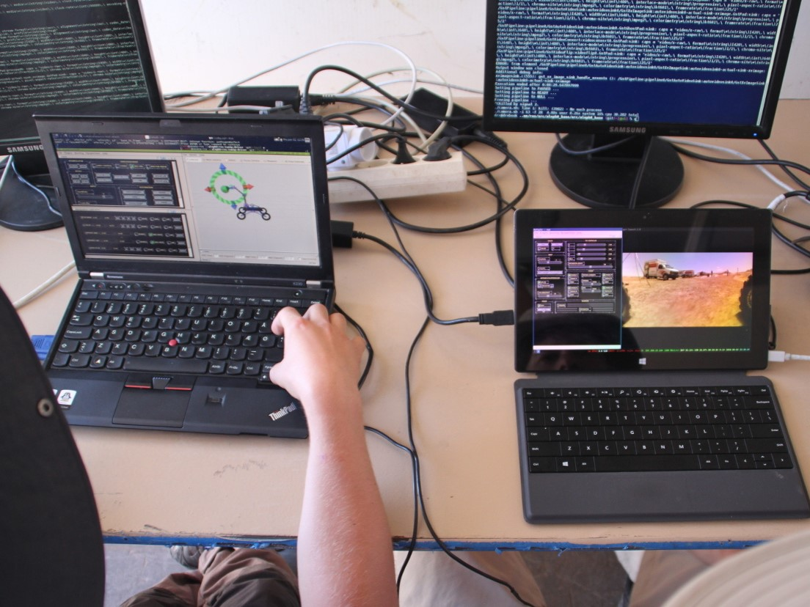

**Fig. 4** Team Continuum’s base station setup. A screenshot of their rover control GUI can be seen in Fig. 5.

The main component that allows the team to control the arm is the inverse kinematics software (python source code[7]). By utilizing four relative encoders placed on the joints of the manipulator, the operator is not only able to observe the visualization of the rover, but he can also give more intuitive commands to the effector. For example, with this system it is possible to move the gripper up, down, front or back and the speeds of all the motors are automatically adjusted to reach given position.

There is one big advantage of such a system, that has proven to be very helpful during the competition: even when the data connection is not good, it is possible to operate the manipulator. As soon as the instruction reaches the rover, the arm will position itself in the correct way. This would not be true in the conventional way of controlling robots, where usually the device is performing some actions as long as a button is being pressed and the operator needs to depend on a feedback from the cameras, which might be delayed or even not available.

Team Continuum also implemented a "semi-automatic actuator switching and picking up things" system for the ERC 2016, because such functionality provided bonus points for the ranking. It was not deployed during the URC 2017. We have decided to present it in this section, because it is an interesting example of relatively simple extension to the already described system, letting it perform much more complex tasks.

To get additional points the team must have positioned the effector at least 20cm from the object it wanted to pick up or the switch. Then, the operator should announce he is starting the autonomous mode and put down the controller. Next, the rover should pick up the object or switch the actuator and move back at least 20cm.

The team decided to implement a simple idea: they wanted to place the effector **exactly** 20cm from the object and directly in front of it. Then, using the *inverse kinematics* system they were able to execute pre-recorded movements in order to complete the task.

The first challenge they have faced was how to measure exactly the distance from object. They decided to mount two laser pointers on the effector. They can be seen in multiple scenes of the recently released video[8] from the University of Wrocław. The two dots meet exactly at 20cm.

Two arm movements were programmed:

* For switching actuators, the effector went forward for 20cm and 2.5cm down simultaneously, then up for 5cm and back to the initial position (20cm back and 2.5cm down). Due to the mechanical construction and the softness of the end of the arm, Aleph1 was able to switch most of the actuators using this technique, both very small and big ones.
* For picking things up the effector goes down 20cm, then the grip motor engages until the force measurement on this motor crosses a predetermined threshold, then it goes back up 20cm.

The arm of the Aleph1 rover is far from the state of the art manipulators. It is not as fast or precise as it could be and the control sometimes is tricky. However, even though the described solutions might seem simple it was still one of the most advanced robotic arms on URC 2017. It is hard to construct a robust and fail-proof manipulator, that is mountable on the movable platform and at the same time fits in the strict mass and costs limits of URC. The Continuum team has proven that this is possible and the capabilities of such simple platform can be exceptional.

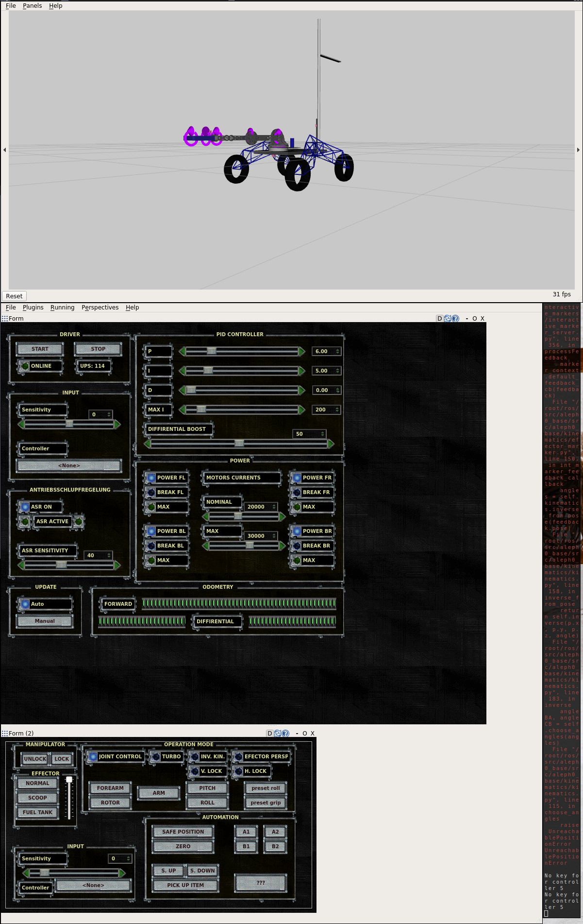

Fig. X The 3D visualization of the Aleph1 rover used by the team during teleoperation.



Fig. Y Team Continuum's GUI used to control the movements of the rover.



**Fig. Z** Team Continuum's GUI used to control the manipulator of the rover..

# ROS Environment

## H:\Dropbox\Dropbox\ROSBook\Rover Diagram.pngROS Software Architecture in Team R3’s Rover

**Fig. 6** ROS software architecture of Team R3’s rover.

At team R3, our ROS software had five main systems: the drive system, the autonomous system, the global positioning system, the visual feedback system, and the odometry system. The full diagram, as seen in figure 6, has been made available in Microsoft Visio format[9].

To learn more about each software component we have provided links to the most relevant documentation.

### Autonomous System

Team R3’s autonomous system consists of the ZED depth camera and the RTAB-Map ROS package for SLAM mapping. The authors have also contributed gps_goal and follow_waypoints ROS packages for added goal setting convenience.

1. zed-ros-wrapper1 – <http://wiki.ros.org/zed-ros-wrapper>

2. follow_waypoints.py2 – <http://wiki.ros.org/follow_waypoints>

3. rgbd_odometry3 – [http://wiki.ros.org/rtabmap_ros#rgbd_odometry](http://wiki.ros.org/rtabmap_ros)

4. rtabmap4 – <http://wiki.ros.org/rtabmap_ros>

21. gps_goal.py21 – <http://wiki.ros.org/gps_goal>

Listing Autonomous system software used in Team R3’s rover.

### Odometry System

At the URC competition teams are surrounded by sandy desert terrain in Utah. As a result of wheel slippage on sand, Team R3 did not use wheel odometry. Instead we focused on fusing IMU and visual odometry into a more reliable position and orientation. However, because our IMU was not working well enough to produce a good fused result, at the competition we did not actually use the ekf_localization ROS nodes of the odometry system. Instead we relied on odemetry from the rgbd_odometry ROS node only and this worked well for our autonomous system based on the RTAB-Map package.

5. ekf_localization5 – <https://github.com/danielsnider/simple_drive/blob/master/launch/cmd_vel_mux.launch>

6. rtimulib_ros6 – <https://github.com/romainreignier/rtimulib_ros>

7. navsat_transform7 – <http://docs.ros.org/lunar/api/robot_localization/html/navsat_transform_node.html>

8. nmea_navsat_driver8 – <http://wiki.ros.org/nmea_navsat_driver>

Listing Odometry software components used in Team R3’s rover.

### Drive System

The drive software created by Team R3 is called simple_drive because it does not produce wheel odometry or transforms. That is left to the autonomous system via SLAM and is more robust in slippery desert environments. The simple_drive package controls 6 motors with PWM pulses using an Arduino dedicated to driving. For further details of the drive system see section 5.3.

9. joy9 – <http://wiki.ros.org/joy>

10. drive_teleop.py10 – [http://wiki.ros.org/simple_drive#drive_teleop](http://wiki.ros.org/simple_drive)

11. cmd_vel_mux.py11 – [http://wiki.ros.org/simple_drive#cmd_vel_mux](http://wiki.ros.org/simple_drive)

12. simple_drive.py12 – [http://wiki.ros.org/simple_drive#simple_drive-1](http://wiki.ros.org/simple_drive)

Listing Drive system software used in Team R3’s rover.

### Navigation Stack

The navigation stack used by Team R3 follows the commonly used development patterns of the ROS navigation package.[10] Our setting choices were inspired by RTAB-Map’s tutorial[11] and we share our tips in section 5.10.4.

13. move_base13 – <http://wiki.ros.org/move_base>

14. Cost Map (costmap_2d14) – <http://wiki.ros.org/costmap_2d>15. Cost Map (Obstacle Layer15) – <http://wiki.ros.org/costmap_2d/hydro/obstacles>

16. Cost Map (Static Layer16) – <http://wiki.ros.org/costmap_2d/hydro/staticmap>

17. Global Planner (Navfn17) – <http://wiki.ros.org/navfn>

18. Local Planner (base_local_planner::TrajectoryPlannerROS18) – <http://wiki.ros.org/base_local_planner>

Listing Navigation software stack used in Team R3’s rover.

### Visual Feedback

To assist in teleoperation of the robot, sensors and navigation plans were visualized in rviz for local information such as point clouds and in mapviz for a global context that includes satellite imagery. The visual feedback software and joystick software was executed remotely on a laptop in the control station. The rest of software was executed on a Jetson TX1 inside the rover.

19. RViz19 – <http://wiki.ros.org/rviz>

20. rqt_image_view20 – <http://wiki.ros.org/rqt_image_view>

22. MapViz22 – <http://wiki.ros.org/mapviz>

23. usb_cam23 – <http://wiki.ros.org/usb_cam>

Listing Visual feedback software used by Team R3.

# Tutorials

## Tutorial: Autonomous Waypoint Following

**Source code:** <https://github.com/danielsnider/follow_waypoints>

**Wiki page:** <http://wiki.ros.org/follow_waypoints>

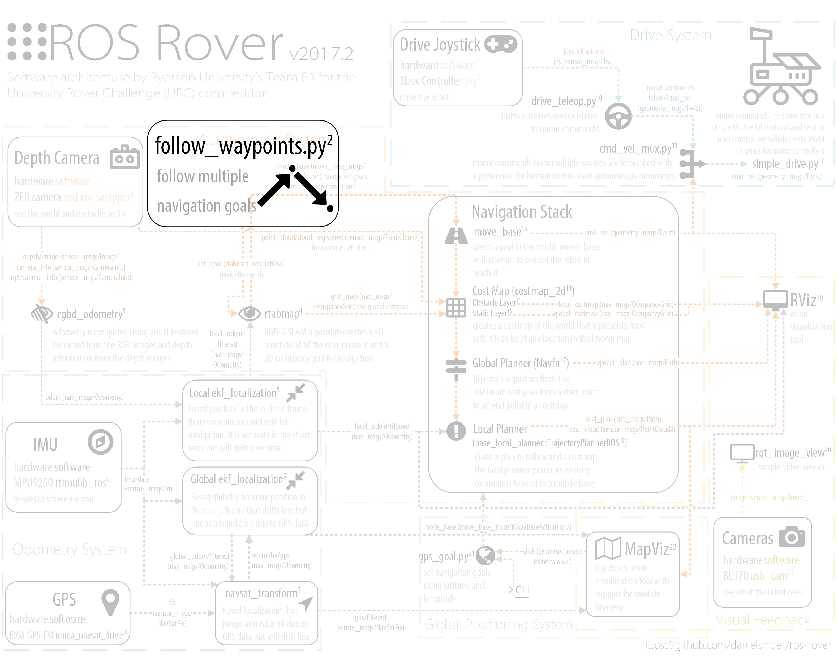

**Fig. 7** ROS node follow_waypoints as seen in the larger architecture diagram. See section 4.1 for the full diagram.

If you can autonomously navigate from A to B, then you can combine multiple steps of A to B to form more complicated paths and use cases. For example, do you want your rover to take the scenic route? Are you trying to reach your goal and come back? Do you need groceries on the way home from Mars? The following tutorial documents a short script that will buffer move_base goals until instructed to navigate to them in sequence.

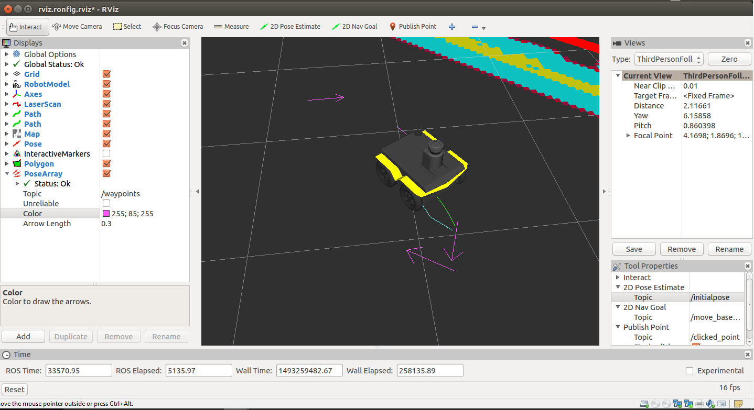

**Fig. 8** A simulated Clearpath Jackal robot[12] navigating to one of several waypoints displayed as pink arrows.

Team R3 has developed the follow_waypoints ROS package which uses actionlib to send the goals to move_base in a robust manner.

The code structure of follow_waypoints.py is a barebones state machine. For this reason it is easy to add complex behavior controlled by state transitions. For modifying the script to be an easy task, you should learn about the Python state machine library in ROS called smach.[13][14] The state transitions in the script occur in the order GET_PATH (buffers goals into a path list), FOLLOW_PATH, and PATH_COMPLETE and then they repeat.

### Usage in the **University Rover** Challenge (URC)

A big advantage of waypoint following is that the rover can go to points beyond reachable by Wi-Fi. In the autonomous traversal task, Team ITU’s rover at one point lost connection, but then got it back again when it reached the waypoint.

Other possible uses of waypoint following:

* To navigate to multiple goals in the autonomous task with a single command (use in combination with GPS goals, see Section 5.11)
* To search a variety of locations, ideally faster than by teleoperation
* To allow for human assisted obstacle avoidance where an obstacle is known to fail detection

### Usage Instructions

1. Install the ROS package:

$ sudo apt-get install ros-kinetic-follow-waypoints

2. Launch the ROS node:

$ roslaunch follow_waypoints follow_waypoints.launch

3. To set waypoints you can either publish a ROS Pose message to the /initialpose topic directly or use RViz’s tool “2D Pose Estimate” to click anywhere. Fig. 7 shows the pink arrows representing the current waypoints in RViz. To visualize the waypoints in this way, use the topic /current_waypoints, published by follow_waypoints.py as a PoseAarray type.

4. To initiate waypoint following send a “path ready” message.

$ rostopic pub /path_ready std_msgs/Empty -1

To cancel the goals do the following. This is the normal move_base command to cancel all goals.

$ rostopic pub -1 /move_base/cancel actionlib_msgs/GoalID -- {}

### Normal Output

When you launch and use the follow_waypoints ROS node you will see the following console output.

$ roslaunch follow_waypoints follow_waypoints.py

[INFO] : State machine starting in initial state 'GET_PATH' with userdata: ['waypoints']

[INFO] : Waiting to receive waypoints via Pose msg on topic /initialpose

[INFO] : To start following waypoints: 'rostopic pub /path_ready std_msgs/Empty -1'

[INFO] : To cancel the goal: 'rostopic pub -1 /move_base/cancel actionlib_msgs/GoalID -- {}'

[INFO] : Received new waypoint

[INFO] : Received new waypoint

[INFO] : Received path ready message

[INFO] : State machine transitioning 'GET_PATH':'success'-->'FOLLOW_PATH'

[INFO] : Executing move_base goal to position (x,y): 0.0123248100281, -0.0620594024658

[INFO] : Executing move_base goal to position (x,y): -0.0924506187439, -0.0527720451355

[INFO] : State machine transitioning 'FOLLOW_PATH':'success'-->'PATH_COMPLETE'

[INFO] : ###############################

[INFO] : ##### REACHED FINISH GATE #####

[INFO] : ###############################

[INFO] : State machine transitioning 'PATH_COMPLETE':'success'-->'GET_PATH'

[INFO] : Waiting to receive waypoints via Pose msg on topic /initialpose

## Tutorial: Image Overlay Scale and Compass

**Source code:** <https://github.com/danielsnider/image_overlay_scale_and_compass>

**Wiki page:** <http://wiki.ros.org/image_overlay_scale_and_compass>

In an effort to add context about of the world to imagery recorded, we have have developed a ROS package image_overlay_compass_and_scale that can add an indication of scale and compass to images and video streams. A compass graphic will be embedded into imagery in a way that makes north direction apparent. A scale bar is also added so that the size of objects in images is more easily interpreted.

Compass and scale values must be provided using standard ROS Float32 messages. Alternatively, a command interface can be used without ROS.

This tool meets one of the requirements of URC 2017 (in an automated way) and is applied to images of soil sampling sites and scenic panoramas for scientific and geological purposes.

This package uses OpenCV’s python library to overlay the fixed size scale bar and text and

The implementation of overlaying the compass graphic on the input image follows these steps: 1) resize the compass to be 60% the size of the input image’s smaller side (whichever is smaller, x or y resolution). 2) Rotate the compass to the degrees specified on the /heading input topic. 3) Warp the compass to make it appear that the arrow is pointing into the image. This assumes that the input image has a view forward facing with the sky in the upper region of the image.

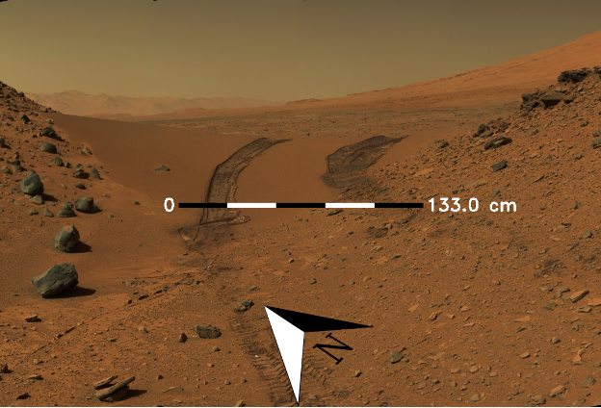

**Fig. 9** Example of the image_overlay_compass_and_scale ROS package.

### Quick Start

1. Install:

$ sudo apt-get install ros-kinetic-image-overlay-compass-and-scale

2. Launch node:

$ roslaunch image_overlay_compass_and_scale overlay.launch

3. Publish heading and scale values

$ rostopic pub /heading std_msgs/Float32 45 # unit is degrees

$ rostopic pub /scale std_msgs/Float32 133 # unit is centimeters

4. View resulting image

$ rqt_image_view /overlay/compressed

### Command Line Interface (CLI)

Invoke once using the Command Line Interface (CLI) to save the image overlay to disk instead of publishing to ROS.

$ roscd image_overlay_compass_and_scale

$ ./src/image_overlay_compass_and_scale/image_overlay.py --input-image ~/mars.png --heading 45 --scale-text 133 --output-file output.png

**CLI Options**

Usage: image_overlay.py [OPTIONS]

Options:

--input-image TEXT Path to input image file [required]

--heading FLOAT Current heading relative to north in degrees [required]

--scale-text FLOAT The value to be displayed on the right of the scale bar

in centimeters [required]

--output-file TEXT Output filename to save result to

[default='output.png']

--help Show this message and exit.

### Subscribed Topics

camera/compressed ([sensor_msgs/CompressedImage](http://docs.ros.org/api/sensor_msgs/html/msg/CompressedImage.html))

Image topic that will be overlaid with scale and compass indicators.

heading ([std_msgs/Float32](http://docs.ros.org/api/std_msgs/html/msg/Float32.html))

Current heading relative to north in degrees.

scale ([std_msgs/Float32](http://docs.ros.org/api/std_msgs/html/msg/Float32.html))

The value to be displayed on the right of the scale bar in centimeters.

### Published Topics

overlay/compressed ([sensor_msgs/CompressedImage](http://docs.ros.org/api/sensor_msgs/html/msg/CompressedImage.html))

The resulting image overlaid with scale and compass indicators.

### Parameters

~framerate (int, default: 3)

The rate at which to publish an image overlaid with scale and compass indicators.

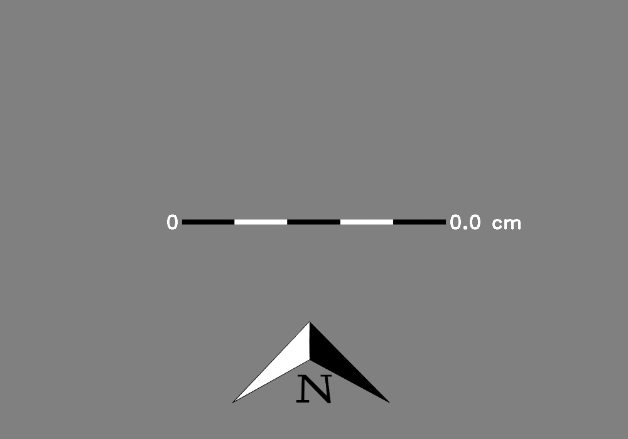

**Fig. 10** This is what to expect when nothing is received by the node. This is the default published image.

## Tutorial: A Simple Drive Software Stack

**Source code:** <https://github.com/danielsnider/simple_drive>

**Wiki page:** <http://wiki.ros.org/simple_drive>

The authors have published a new ROS package for used at URC to drive Team R3’s rover. It proved simple and effective in desert conditions. The package is simple in the sense that it does not publish TF odometry from wheel encoders because such goal would be futile on sand where wheels slip substantially. The package does implement includes skid steering joystick teleoperation, control of a panning servo to look around the robot, and Arduino firmware.

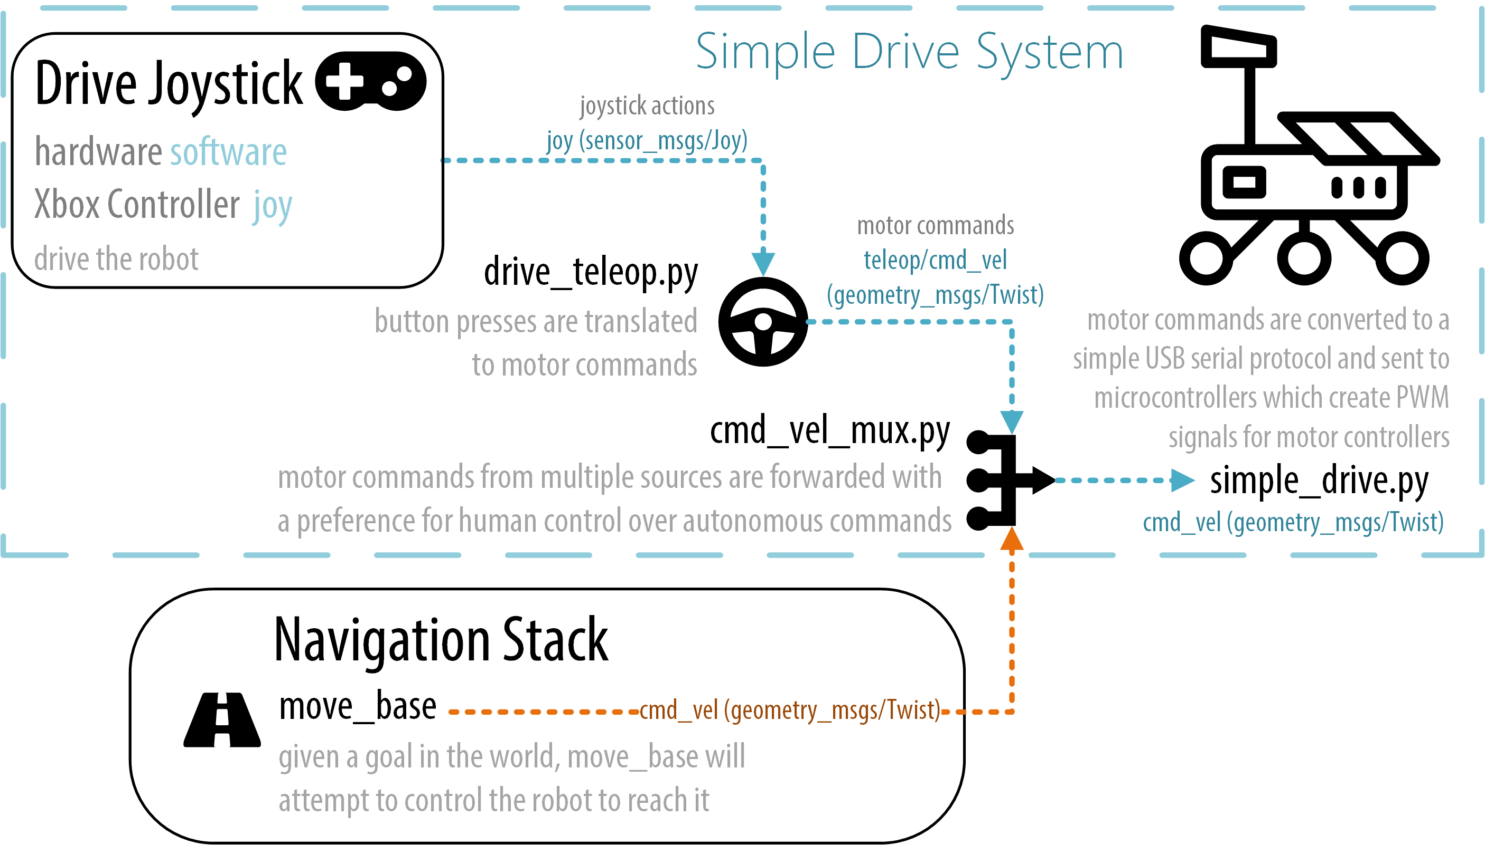

**Fig. 11** Architecture of the drive software used by Team R3. See section 4.1 for a larger diagram.

Features include:

* skid steering joystick teleoperation with three drive speeds
* joystick control of a servo (left and right only)
* dedicated left and right thumbsticks for left and right wheel speeds
* a cmd_vel multiplexer to support a coexisting autonomous drive system
* simple Arduino firmware to talk to PWM motors and a servo

For the sake of simplicity, this package does not do the following:

* [tf](http://wiki.ros.org/tf) publishing of transforms
* wheel odometry publishing
* PID control loop
* integration with [ros_control](http://wiki.ros.org/ros_control)

This package is divided into four parts:

|  |  |
| --- | --- |
| **Nodes** | **Purpose** |
| [drive_teleop](http://wiki.ros.org/simple_drive#drive_teleop) | Drive your robot with a joystick in skid steering mode (also known as diff drive or tank drive). Left joystick thumbstick controls left wheels, right thumbstick controls right wheels. |
| [cmd_vel_mux](http://wiki.ros.org/simple_drive#cmd_vel_mux) | Motor commands from multiple sources are forwarded with a preference for human control over autonomous commands. |
| [simple_drive](http://wiki.ros.org/simple_drive#simple_drive) | Send motor commands to your microcontroller. |
| [drive_firmware](http://wiki.ros.org/simple_drive#drive_firmware) | Microcontroller software that controls your motors. Not a ROS node. |

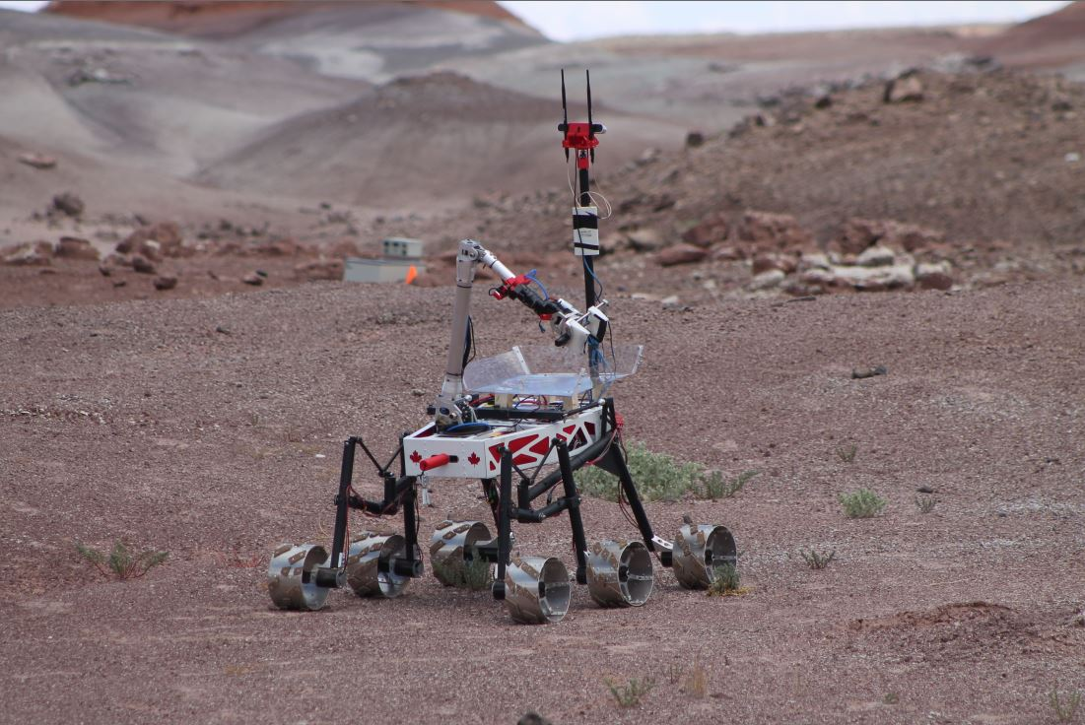

**Fig. 12** Team R3’s rover being teleoperated by simple_drive.

### Quick Start

1. Install:

$ sudo apt-get install ros-kinetic-simple-drive

2. Launch:

$ roslaunch simple_drive drive_teleop.launch joy_dev:=/dev/input/js0

$ roslaunch simple_drive cmd_vel_mux.launch

$ roslaunch simple_drive simple_drive.launch serial_dev:=/dev/ttyACM0

OR all-in-one launch:

$ roslaunch simple_drive drive.launch

3. Install the [drive_firmware](http://wiki.ros.org/simple_drive#drive_firmware) onto a microcontroller connected to your motors and wheels by PWM. The microcontroller must also be connected to the computer running the simple_drive ROS node by a serial connection (eg. USB).

4. Drive your robot around.

### drive_teleop ROS Node

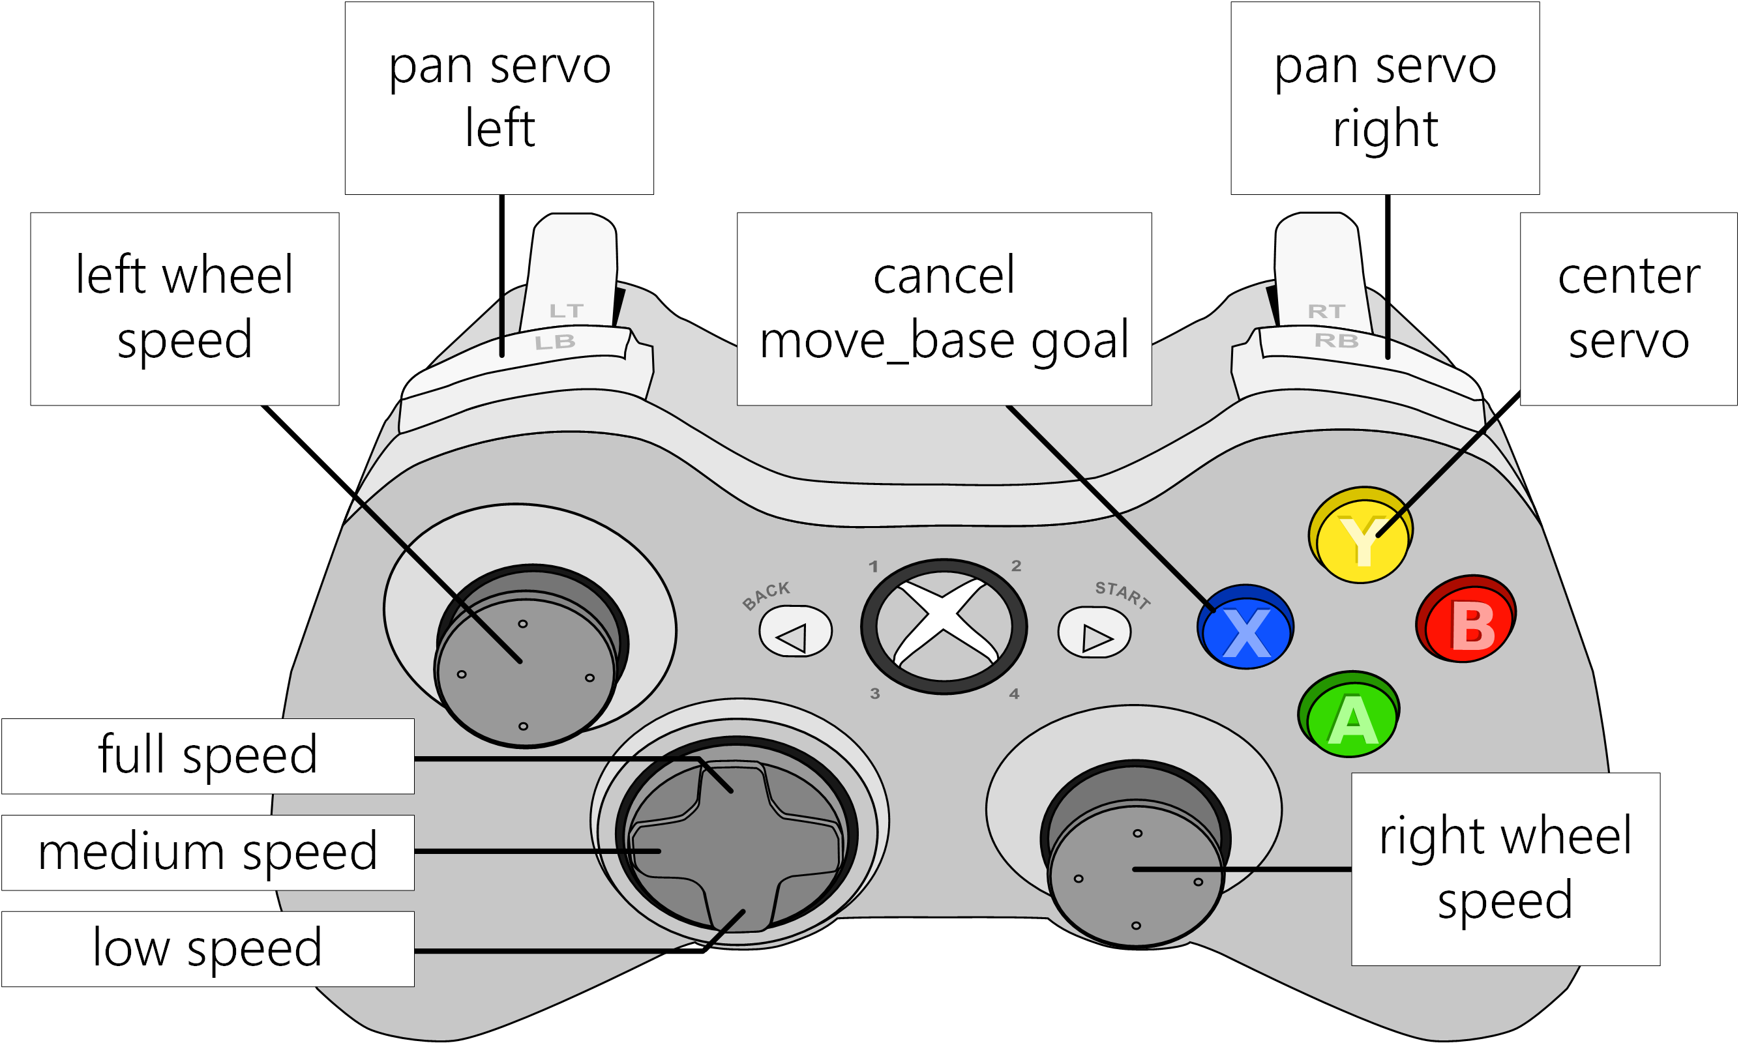

**Fig. 13** The Xbox 360 joystick button layout for the simple_drive package (diagram is available in Visio format[15]).

This node converts [sensor_msgs/Joy](http://docs.ros.org/api/sensor_msgs/html/msg/Joy.html) messages from the [joy](http://wiki.ros.org/joy) ROS node into a variety of commands to drive the robot at low, medium, and high speed, look around with a servo, and cancel move_base goals at any moment. The drive_teleop node simply sends commands to other nodes. Typically the servo is used to move a camera so that the teleoperator can look around the robot.

The button mapping was tested on an Xbox 360 controller and should require little or no modification for similar controllers, as long as they are in DirectInput mode.

**Launch example**

$ roslaunch simple_drive drive_teleop.launch joy_dev:=/dev/input/js0

#### Subscribed Topics

joy ([sensor_msgs/Joy](http://docs.ros.org/api/sensor_msgs/html/msg/Joy.html))

Controller joystick button presses are received on this topic. See [joy](http://wiki.ros.org/joy) node for more info.

#### Published Topics

teleop/cmd_vel ([geometry_msgs/Twist](http://docs.ros.org/api/geometry_msgs/html/msg/Twist.html))

Output motion commands that drive the robot.

servo_pos ([std_msgs/Float32](http://docs.ros.org/api/std_msgs/html/msg/Float32.html))

Output servo commands that control the angle of a servo.

#### Parameters

~servo_pan_speed (int, default: 5)

The degrees of servo motion per button press.

~servo_pan_max (int, default: 160)

The maximum angle of servo rotation in degrees.

~servo_pan_min (int, default: 0)

The minimum angle of servo rotation in degrees.

### cmd_vel_mux ROS Node

The cmd_vel_mux node receives movement commands on two [sensor_msgs/Twist](http://docs.ros.org/api/sensor_msgs/html/msg/Twist.html) topics, one for teleoperation and one for autonomous control, typically [move_base](http://wiki.ros.org/move_base). Movement commands are multiplexed to a final topic for robot consumption. If any teleoperation command is received autonomous commands are blocked for a set time defined by the block_duration parameter.

**Launch example**

$ roslaunch simple_drive cmd_vel_mux.launch

#### Subscribed Topics

teleop/cmd_vel ([geometry_msgs/Twist](http://docs.ros.org/api/geometry_msgs/html/msg/Twist.html))

Human generated movement commands from a teleoperation node such as the [drive_teleop](http://wiki.ros.org/simple_drive#drive_teleop) node.

move_base/cmd_vel ([geometry_msgs/Twist](http://docs.ros.org/api/geometry_msgs/html/msg/Twist.html))

Computer generated movement commands from an autonomous system such as [move_base](http://wiki.ros.org/move_base) or [rtabmap_ros](http://wiki.ros.org/rtabmap_ros).

#### Published Topics

cmd_vel ([geometry_msgs/Twist](http://docs.ros.org/api/geometry_msgs/html/msg/Twist.html))

Movement commands for consumption by the robot. Autonomous movement commands will be blocked for block_duration seconds if any teleoperation command is received.

#### Parameters

~block_duration (int, default: 5)

The amount of time autonomous movement is blocked after any human movement is received.

### simple_drive ROS Node

This node communicates with a microcontroller over serial using the protocol defined by drive_firmware. This protocol is designed to be very simple, and prioritizes simplicity over integrity of messages. A diagram showing how this data is encoded over the serial connection is below in Fig. 13.

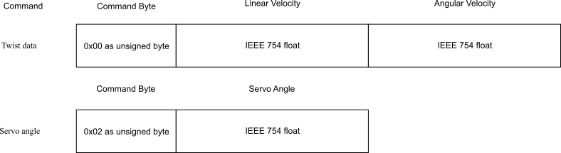

**Fig 13.** Diagram of the format used by drive_firmware

 If your microcontroller supports subscribing to ROS twist messages (Arduinos can use [rosserial_arduino](http://wiki.ros.org/rosserial_arduino)) then it would be simpler to do that and skip this node. However, this node is written in python so you could more easily add complex functionality in python and then in your microcontroller do the minimum amount of work necessary.

**Launch example**

$ roslaunch simple_drive simple_drive.launch serial_dev:=/dev/ttyACM0

#### Subscribed Topics

cmd_vel ([geometry_msgs/Twist](http://docs.ros.org/api/geometry_msgs/html/msg/Twist.html))

Motor commands received on this topic are encoded and sent over serial to the [drive_firmware](http://wiki.ros.org/simple_drive#drive_firmware).

servo_pos ([std_msgs/Float32](http://docs.ros.org/api/std_msgs/html/msg/Float32.html))

Servo position commands received on this topic are encoded and sent over serial to the [drive_firmware](http://wiki.ros.org/simple_drive#drive_firmware).

#### Parameters

~serial_dev (string, default: /dev/ttyACM0)

The microcontroller, often an Arduino, as seen in linux, that this node will send motor commands to.

~baudrate (int, default: 9600)

Sets the serial device data transmission rate in bits per second (baud).

### drive_firmware

The drive_firmware microcontroller code does the minimum amount of work possible to receive motor commands from a USB serial connection and output voltages to digital PWM output to be received by motor controllers.

We connected an Arduino by USB serial to our main robot computer and dedicated its use to the simple_drive package. We tested on an Arduino Mega 2560 and Arduino Due, however many other boards should work with the same code and setup steps thanks to PlatformIO. You may need to change to change the pin numbers.

 Caution! This software does not stop moving the robot if no messages are received for certain period of time. A pull request for this is very welcome.

**PlatformIO**

We deploy the drive_firmware to an Arduino microcontroller using PlatformIO. We like PlatformIO for their tagline, "Single source code. Multiple platforms." PlatformIO supports approximately 200 [Embedded Boards](http://platformio.org/boards) and all major [Development Platforms](http://docs.platformio.org/en/latest/platforms/index.html#platforms). Learn more on [platformio.org](http://platformio.org/).

**Install and configure drive_firmware**

This steps were tested on Ubuntu 16.04.

**1. Install PlatformIO**

$ sudo python -c "$(curl -fsSL https://raw.githubusercontent.com/platformio/platformio/master/scripts/get-platformio.py)"

# Enable Access to Serial Ports (USB/UART)

$ sudo usermod -a -G dialout <your username here>

$ curl https://raw.githubusercontent.com/platformio/platformio/develop/scripts/99-platformio-udev.rules  > /etc/udev/rules.d/99-platformio-udev.rules

# After this file is installed, physically unplug and reconnect your board.

$ sudo service udev restart

More PlatformIO install information: <http://docs.platformio.org/en/latest/installation.html#super-quick-mac-linux>

**2. Create a PlatformIO project**

$ roscd simple_drive

$ cd ./drive_firmware/

# Find the microcontroller that you have in the list of PlatformIO boards

$ pio boards | grep -i mega2560

# Use the name of your board to initialize your project

$ pio init --board megaatmega2560

More PlatformIO info: <http://docs.platformio.org/en/latest/quickstart.html>

**3. Modify wiring if necessary**

$ vim src/main.cpp +4

Depending on how you want to wire your microcontroller this wiring could be changed:

[1](http://wiki.ros.org/simple_drive#CA-dc44dba10006d6fecefa58eb789589c98d122c17_1) // Pins to Left Wheels

[2](http://wiki.ros.org/simple_drive#CA-dc44dba10006d6fecefa58eb789589c98d122c17_2) #define pinL1 13

[3](http://wiki.ros.org/simple_drive#CA-dc44dba10006d6fecefa58eb789589c98d122c17_3) #define pinL2 12

[4](http://wiki.ros.org/simple_drive#CA-dc44dba10006d6fecefa58eb789589c98d122c17_4) #define pinL3 11

[5](http://wiki.ros.org/simple_drive#CA-dc44dba10006d6fecefa58eb789589c98d122c17_5) // Pins to Right Wheels

[6](http://wiki.ros.org/simple_drive#CA-dc44dba10006d6fecefa58eb789589c98d122c17_6) #define pinR1 9

[7](http://wiki.ros.org/simple_drive#CA-dc44dba10006d6fecefa58eb789589c98d122c17_7) #define pinR2 8

[8](http://wiki.ros.org/simple_drive#CA-dc44dba10006d6fecefa58eb789589c98d122c17_8) #define pinR3 7

[9](http://wiki.ros.org/simple_drive#CA-dc44dba10006d6fecefa58eb789589c98d122c17_9) // Pin to the Servo

[10](http://wiki.ros.org/simple_drive#CA-dc44dba10006d6fecefa58eb789589c98d122c17_10) #define pinServo 5

**4. Modify PWM Settings**

$ vim src/main.cpp +17

Edit the following section to match your motor controller PWM specs:

[1](http://wiki.ros.org/simple_drive#CA-6637c11158e6caa90fc0df1b73d2377f7e8c703e_1) // PWM specs of the Spark motor controller. Spark manual:

[2](http://wiki.ros.org/simple_drive#CA-6637c11158e6caa90fc0df1b73d2377f7e8c703e_2) // http://www.revrobotics.com/content/docs/LK-ATFF-SXAO-UM.pdf

[3](http://wiki.ros.org/simple_drive#CA-6637c11158e6caa90fc0df1b73d2377f7e8c703e_3) #define sparkMax 1000 // Default full-reverse input pulse

[4](http://wiki.ros.org/simple_drive#CA-6637c11158e6caa90fc0df1b73d2377f7e8c703e_4) #define sparkMin 2000 // Default full-forward input pulse

**5. Deploy Code to Arduino**

$ pio run --target upload

**6. Your robot is now ready to be driven.**

### Other Implementation Details

**Tank to Twist Calculation**

When a left and right joystick inputs are received by the [drive_teleop](http://wiki.ros.org/simple_drive#drive_teleop) node, representing left and right wheel velocities (ie. skid steering or differential drive), a [geometry_msgs/Twist](http://docs.ros.org/api/geometry_msgs/html/msg/Twist.html) with linear and rotational velocities is calculated as:

**Linear velocity (m/s) =**

(left_speed + right_speed) / 2.0

**Angular velocity (rad/s) =**

(right_speed - left_speed) / 2.0

**Twist to Tank Calculation**

When a [geometry_msgs/Twist](http://docs.ros.org/api/geometry_msgs/html/msg/Twist.html) containing linear and rotational velocities is received by the [drive_firmware](http://wiki.ros.org/simple_drive#drive_firmware), wheel velocities are calculated as:

**Left wheel velocity (m/s) =**

linear_speed + angular_speed

**Right wheel velocity (m/s) =**

linear_speed - angular_speed

### Related Packages

**Similar to**[**simple_drive**](http://wiki.ros.org/simple_drive#simple_drive)**:**

<http://wiki.ros.org/differential_drive> - Differential drive software with support for a velocity PID target, a small GUI to control the robot, and more.

<http://wiki.ros.org/diff_drive_controller> - Differential drive software that is real-time safe, integrates with [ros_control](http://wiki.ros.org/ros_control), and more.

**Similar to**[**drive_teleop**](http://wiki.ros.org/simple_drive#drive_teleop)**:**

<http://wiki.ros.org/teleop_twist_joy> - This teleop node converts joy messages to twist messages.

<http://wiki.ros.org/joy_teleop> - This teleop node takes joy messages and publishes topics or calls actions according a configuration file.

**Similar to**[**cmd_vel_mux**](http://wiki.ros.org/simple_drive#cmd_vel_mux)**:**

<http://wiki.ros.org/twist_mux> - Multiplex several velocity command topics with prioritization or disabling according to a configuration file.

## Tutorial: Velocity Controlled Arm

**Source code:** <https://github.com/danielsnider/simple_arm>

**Wiki page:** <http://wiki.ros.org/simple_arm>

In this tutorial will we will look at teleoperation software and firmware for a simple, velocity controlled arm with 6 degrees of freedom. At the URC competition the rover’s manipulator arm is probably the most important component because it is needed for a large portion of point awarding tasks. It is also very complex. Team R3 ran out of development time to integrate position encoders with MoveIt!, so the arm software that went to URC was simple. Forces input by the operator on individual joystick motions were converted to individual motor velocities. In the science URC mission, the arm was used to drill soil and collect samples. In the extreme delivery and retrieval mission, as well as the equipment servicing task the arm was used heavily for a variety of tasks such as unscrewing a cap and pouring a liquid container or carrying hand tools and small rocks.

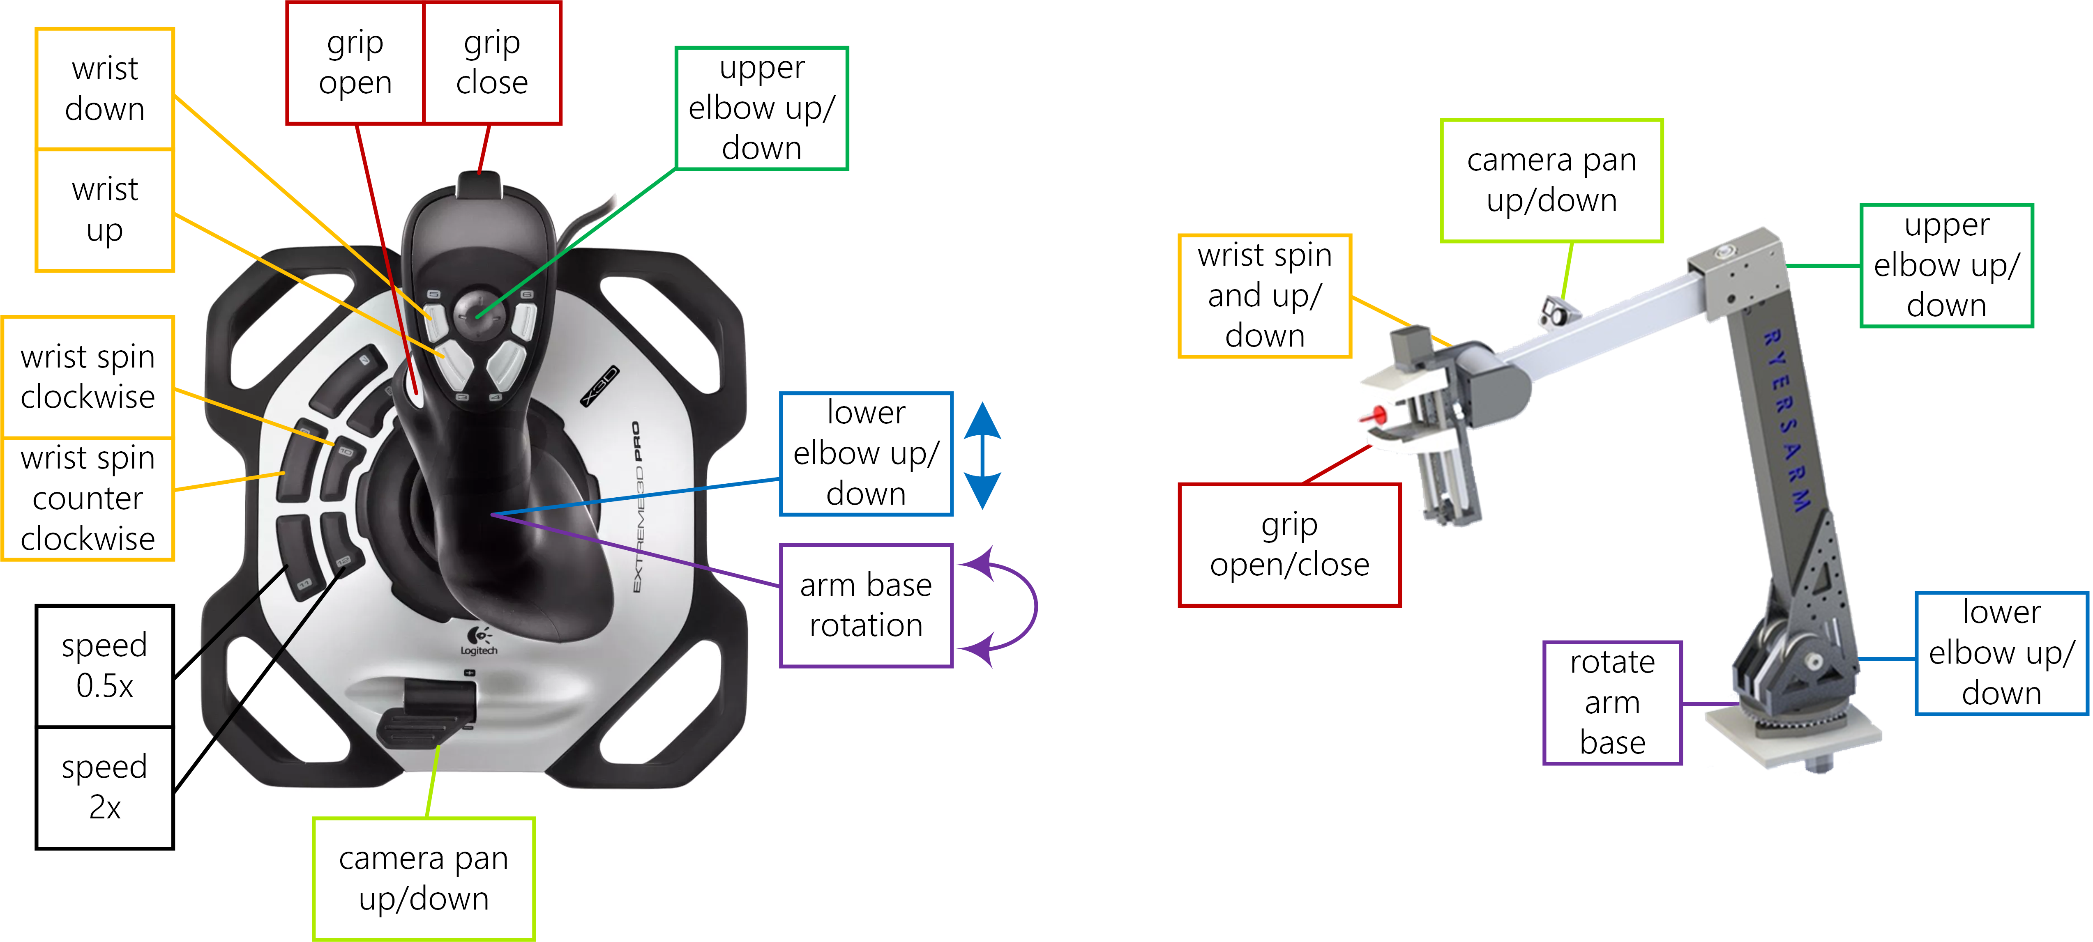

**Fig. 14** The Logitech Extreme 3D Pro joystick button layout for the simple_arm package (diagram is also available in Visio format[16]).

**Features of the package include:**

* velocity control of arm joint motors
* fast and slow motor speed modifier buttons
* open and close a gripper (single speed)
* control of a camera servo (up and down only)
* simple Arduino firmware to talk to PWM motors and a servo

For the sake of simplicity, this package **does not do the following:**

* no [tf](http://wiki.ros.org/tf) publishing
* no URDF
* no PID control loop
* no integration with [ros_control](http://wiki.ros.org/ros_control) or [MoveIt](http://wiki.ros.org/MoveIt)!

### Usage instructions

1. Install the package:

$ sudo apt-get install ros-kinetic-simple-arm

2. Launch the ROS node and specify as arguments the joystick device path for teleoperation and the Arduino to control the arm motor:

$ roslaunch simple_arm simple_arm.launch joystick_serial_dev:=/dev/input/js0 microcontroller_serial_dev:=/dev/ttyACM0

Alternatively, the joystick can be connected to another computer. If you do so the joy ROS node must be run separately.

3. Install the [arm_firmware](http://wiki.ros.org/simple_arm#arm_firmware) onto a microcontroller connected to the arm joint motors by PWM. The microcontroller must also be connected to the computer running the simple_arm ROS node by a serial connection (ex. USB).

4. Move your robot arm.

simple_arm ROS Node

This node converts [sensor_msgs/Joy](http://docs.ros.org/api/sensor_msgs/html/msg/Joy.html) messages from the [joy](http://wiki.ros.org/joy) node into a variety of commands that are sent over serial to a microcontroller to drive the robot arm.

The button mapping was tested on a Logitech Extreme 3D Pro joystick and should only need small modifications for similar controllers.

### Subscribed Topics

joy_arm ([sensor_msgs/Joy](http://docs.ros.org/api/sensor_msgs/html/msg/Joy.html))

Joystick state is received on this topic. See the [joy](http://wiki.ros.org/joy) node for more info.

### Parameters

~microcontroller_serial_device (string, default: /dev/ttyACM0)

The microcontroller, often an Arduino, as seen in Linux, that this node will send motor commands to.

~baudrate (int, default: 9600)

The serial device data transmission rate in bits per second (baud).

### Serial Protocol

This node communicates with the [arm_firmware](http://wiki.ros.org/simple_arm#arm_firmware) using a simple serial protocol. Each serial motion command is a list of floats, one for each joint.

**Serial data packet:**

(FLOAT) GRIP,

(FLOAT) WRIST_ROLL,

(FLOAT) WRIST_PITCH,

(FLOAT) UPPER_ELBOW,

(FLOAT) LOWER_ELBOW,

(FLOAT) BASE_YAW,

(FLOAT) CAMERA

### arm_firmware

The arm_firmware microcontroller code does the minimum amount of work possible to receive motor commands from a USB serial connection and output voltages to digital PWM output to be received by motor controllers.

We connected an Arduino by USB serial to our main robot computer and dedicated its use to the simple_arm package. We tested on an Arduino Mega 2560, however many other boards should work with the same code and setup steps thanks to PlatformIO. You may need to change to change the pin numbers.

 Caution! This software does not stop moving the robot if no messages are received for certain period of time. A pull request for this is very welcome.

**PlatformIO**

We deploy the arm_firmware to an Arduino microcontroller using PlatformIO. We like PlatformIO. Its tagline is "Single source code. Multiple platforms." PlatformIO supports approximately 200 [Embedded Boards](http://platformio.org/boards) and all major [Development Platforms](http://docs.platformio.org/en/latest/platforms/index.html#platforms). Learn more on [platformio.org](http://platformio.org/).

**Install and configure arm_firmware**

This steps were tested on Ubuntu 16.04.

**1. Install PlatformIO**

$ sudo python -c "$(curl -fsSL https://raw.githubusercontent.com/platformio/platformio/master/scripts/get-platformio.py)"

# Enable Access to Serial Ports (USB/UART)

$ sudo usermod -a -G dialout <your username here>

$ curl https://raw.githubusercontent.com/platformio/platformio/develop/scripts/99-platformio-udev.rules  > /etc/udev/rules.d/99-platformio-udev.rules

# After this file is installed, physically unplug and reconnect your board.

$ sudo service udev restart

More PlatformIO install info: <http://docs.platformio.org/en/latest/installation.html#super-quick-mac-linux>

**2. Create a PlatformIO project**

$ roscd simple_arm

$ cd ./arm_firmware/

# Find the microcontroller that you have in the list of PlatformIO boards

$ pio boards | grep -i mega2560

# Use the name of your board to initialize your project

$ pio init --board megaatmega2560

More PlatformIO info: <http://docs.platformio.org/en/latest/quickstart.html>

**3. Modify wiring if necessary**

$ vim src/main.cpp +9

Depending on how you want to wire your microcontroller this wiring can be changed:

[1](http://wiki.ros.org/simple_arm#CA-6fec6f92438b5033145313a02487b7565742e74e_1) struct JOINTPINS{

[2](http://wiki.ros.org/simple_arm#CA-6fec6f92438b5033145313a02487b7565742e74e_2) int wrist_roll = 9; // wrist roll pin

[3](http://wiki.ros.org/simple_arm#CA-6fec6f92438b5033145313a02487b7565742e74e_3) int wrist_pitch = 10; // wrist pitch pin

[4](http://wiki.ros.org/simple_arm#CA-6fec6f92438b5033145313a02487b7565742e74e_4) int upper_elbow = 11; // upper elbow pin

[5](http://wiki.ros.org/simple_arm#CA-6fec6f92438b5033145313a02487b7565742e74e_5) int lower_elbow = 12; // lower elbow pin

[6](http://wiki.ros.org/simple_arm#CA-6fec6f92438b5033145313a02487b7565742e74e_6) int base_yaw = 13; // base yaw pin

[7](http://wiki.ros.org/simple_arm#CA-6fec6f92438b5033145313a02487b7565742e74e_7) int grip_enable = A4; // gripper enable pin

[8](http://wiki.ros.org/simple_arm#CA-6fec6f92438b5033145313a02487b7565742e74e_8) int grip_open = A5; // gripper open pin

[9](http://wiki.ros.org/simple_arm#CA-6fec6f92438b5033145313a02487b7565742e74e_9) int grip_close = A6; // gripper close pin

[10](http://wiki.ros.org/simple_arm#CA-6fec6f92438b5033145313a02487b7565742e74e_10) int cam_tilt = 7; // camera servo pin

[11](http://wiki.ros.org/simple_arm#CA-6fec6f92438b5033145313a02487b7565742e74e_11) }pins;

**4. Modify PWM Settings**

$ vim src/main.cpp +4

Edit the following section to match your motor controller PWM specs:

[1](http://wiki.ros.org/simple_arm#CA-ccae9776c25c06fb89801d1b8cf9a9df2707cf59_1) // PWM specs of the Victor SP motor controller.

[2](http://wiki.ros.org/simple_arm#CA-ccae9776c25c06fb89801d1b8cf9a9df2707cf59_2) // https://www.vexrobotics.com/217-9090.html

[3](http://wiki.ros.org/simple_arm#CA-ccae9776c25c06fb89801d1b8cf9a9df2707cf59_3) #define sparkMax 650 // Full-reverse input pulse

[4](http://wiki.ros.org/simple_arm#CA-ccae9776c25c06fb89801d1b8cf9a9df2707cf59_4) #define sparkMin 2350 // Full-forward input pulse

**5. Deploy Code to Arduino**

$ pio run --target upload

**6. Your robot arm is now ready for motion commands.**

## Tutorial: Autonomous Recovery after Lost Communications

**Source code:** <https://github.com/danielsnider/lost_comms_recovery>

**Wiki page:** <http://wiki.ros.org/lost_comms_recovery>

At the URC competition, Team R3 was worried about travelling into a communication deadzone and losing wireless control of our rover from a distant base station. This is one of the challenges put forth by URC competition and is often found in the real world.

We have published a new package that will trigger when the robot loses connection to the base station and it will navigate to a configurable home or stop all motors. The base station connection check uses ping to a configurable list of IPs. The monitoring loop waits 3 seconds between checks and by default failure is triggered after 2 consecutive failed pings. Each ping will wait up to one second to receive a response. Please note that this node is not designed to be “real-time”[17] safe.

### Quick Start

1. Install:

$ sudo apt-get install ros-kinetic-lost-comms-recovery

2. Launch:

$ roslaunch lost_comms_recovery lost_comms_recovery.launch ips_to_monitor:=192.168.1.2

**If move_base is running**

If move_base is running, an autonomous recovery navigation will take place. The default position of the recovery goal is the origin (0,0) of the frame given it the goal_frame_id param and the orientation is all 0s by default. This default pose can be overridden if a messaged is published on the recovery_pose topic. If move_base is already navigating to a goal it will not be interrupted and recovery navigation will happen when move_base is idle.

**If move_base is not running**

If move_base is not running when communication failure occurs then motors and joysticks are set to zero by publishing a zero geometry_msgs/Twist message and a zero sensor_msgs/Joy message.

**Important**: Instead of relying on this this feature, you're better off with motor control software that sets zero velocity after a certain amount of time not receiving any new commands.

lost_comms_recovery ROS Node

### Actions Called

move_base ([move_base_msgs/MoveBaseAction](http://wiki.ros.org/move_base_msgs/MoveBaseAction))

The move_base action server performs the autonomous recovery navigation.

### Subscribed Topics

recovery_pose ([geometry_msgs/PoseWithCovarianceStamped](http://docs.ros.org/api/geometry_msgs/html/msg/PoseWithCovarianceStamped.html))

A pose that the robot will recover to if communication to the base station is lost. This will override the default recovery goal which is to the origin (0,0) of the goal_frame_id param.

### Published Topics

cmd_vel ([geometry_msgs/Twist](http://docs.ros.org/api/geometry_msgs/html/msg/Twist.html))

Send a zero Twist message on this topic when communication to the base station is lost.

joy ([sensor_msgs/Joy](http://docs.ros.org/api/sensor_msgs/html/msg/Joy.html))

Send a zero Joy message on this topic when communication to the base station is lost.

### Parameters

~goal_frame_id (string, default: map)

The [tf](http://wiki.ros.org/tf) frame for move_base goals.

~ping_fail_count (int, default: 2)

Number of pings that must fail for communication to be considered lost. Each ping waits 1 second for a response.

~ips_to_monitor (string, default: 192.168.1.2,192.168.1.3)

Comma separated list of IPs to monitor using ping.

### Normal Output

When you launch and use the lost_comms_recovery ROS node you will see the following console output.

$ roslaunch lost_comms_recovery lost_comms_recovery.launch ips_to_monitor:=192.168.190.136

[INFO] Monitoring base station on IP(s): 192.168.190.136.

[INFO] Connected to base station.

[INFO] Connected to base station.

...

[ERROR] No connection to base station.

[INFO] Executing move_base goal to position (x,y) 0.0, 0.0.

[INFO] Initial goal status: PENDING

[INFO] This goal has been accepted by the simple action server

[INFO] Final goal status: SUCCEEDED

[INFO] Goal reached.

## Tutorial: Stitch Panoramas with Hugin

**Source code:** <https://github.com/danielsnider/hugin_panorama>

**Wiki page:** <http://wiki.ros.org/hugin_panorama>

[Hugin](http://hugin.sourceforge.net/)[18] is professional software popularly used to create panoramic images by compositing and rectifying multiple still images. We have created a package to wrap one high level function of Hugin, the creation of panoramas.

In the science task of the URC competition, teams are awarded points if they document locations of scientific interest such as geological and soil sampling sites with panoramas.

Our package uses the [Hugin command line tools](http://wiki.panotools.org/Panorama_scripting_in_a_nutshell) to compose panoramas in 8 steps according to a well-documented workflow[19]. To summarize, it consists of creating a Hugin project file, finding matching feature control points between images, pruning control points with large error distances, find vertical lines across images to be straighten, doing the straightening and other photometric optimization, optimal cropping, and saving to tiff and compressed png image formats. The compressed panoramic image is published on at output ROS topic. An example panorama can be seen in Fig. 15.

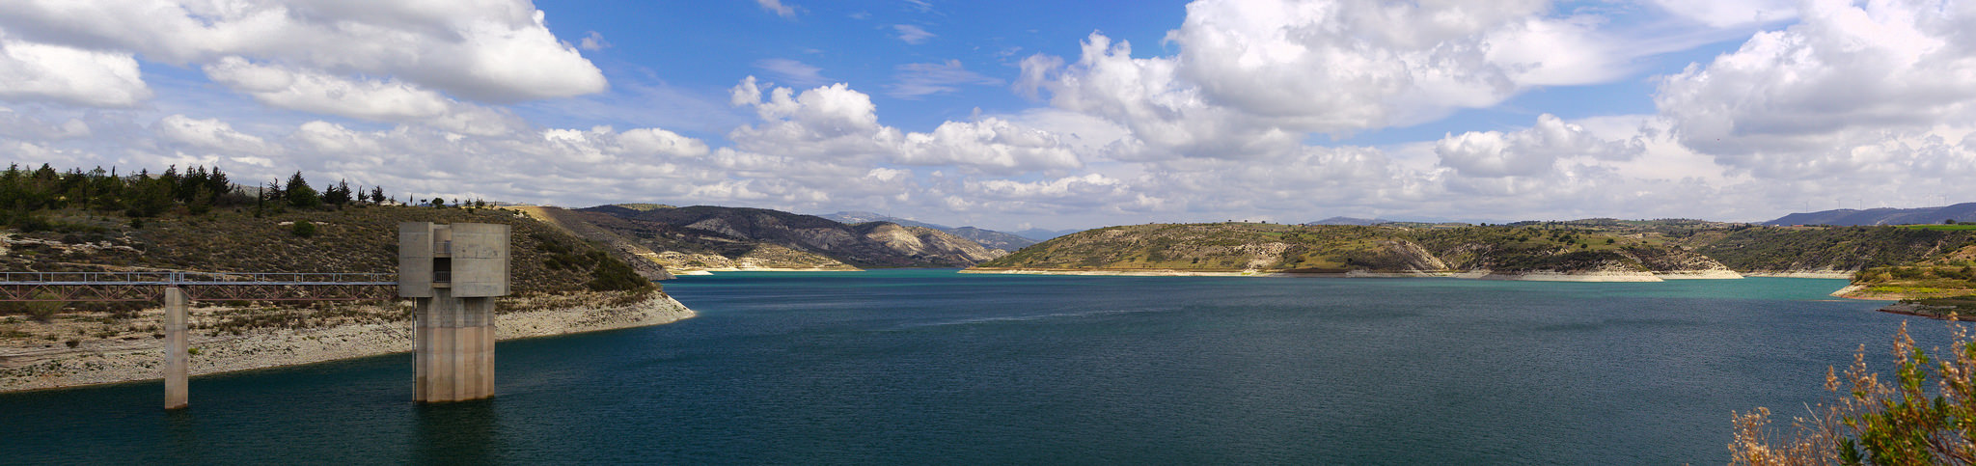

**Fig. 15** Panorama by [Senza Senso](https://www.flickr.com/photos/mesec/25814467750/) (cc).

### Quick Start

1. Install the ROS package:

$ sudo apt-get install ros-kinetic-hugin-panorama hugin-tools enblend

2. Launch the ROS node:

$ roslaunch hugin_panorama hugin_panorama.launch image:=/image_topic

3. Save individual images for input to the panorama: (order doesn't matter)

$ rosservice call /hugin_panorama/image_saver/save

# change angle of camera

$ rosservice call /hugin_panorama/image_saver/save

# repeat as many times as you like...

4. Stitch the panorama:

$ rosservice call /hugin_panorama/stitch

5. View resulting panorama:

$ rqt_image_view /hugin_panorama/panorama/compressed

# or open the panorama file

$ roscd hugin_panorama; eog ./images/output.png

6. Start again:

$ rosservice call /hugin_panorama/reset

This command will clear the images waiting to be stitched so you can start collecting images for an entirely new panorama.

### Live Panorama Mode

If you have more than one camera on your robot and you want to stitch them together repetitively in a loop, then use stitch_loop.launch. However, expect a slow frame rate of less than 1 Hz because this package is not optimized for speed (pull requests welcome).

1. Launch the stitch_loop node:

$ roslaunch hugin_panorama stitch_loop.launch image1:=/image_topic2 image2:=/image_topic2

2. View resulting live panorama:

$ rqt_image_view /hugin_panorama/panorama/compressed

If you have more than two cameras then you'll have to edit the simple python script (rosed hugin_panorama stitch_loop.py) and the launch file (rosed hugin_panorama stitch_loop.launch).

hugin_panorama ROS Node

### Published Topics

panorama/compressed ([sensor_msgs/CompressedImage](http://docs.ros.org/api/sensor_msgs/html/msg/CompressedImage.html))

The resulting panorama.

### Services

stitch ([std_srvs/Empty](http://docs.ros.org/api/std_srvs/html/srv/Empty.html))

Create the panorama.

reset ([std_srvs/Empty](http://docs.ros.org/api/std_srvs/html/srv/Empty.html))

Clear images waiting to be stitched.

### Parameters

~images_path (string, default: “$(find hugin_panorama)/images”)

This is the working directory where input and output images for the panorama are stored.

image_saver ROS Node

This node provided by the [image_view](http://wiki.ros.org/image_view) package allows you to save images as jpg/png file from a [sensor_msgs/Image](http://docs.ros.org/api/sensor_msgs/html/msg/Image.html) topic. The saved images are used when stitching the panoramas. The image_saver node should save images to the same location that the hugin_panorama node will look in when stitching. See [hugin_panorama.launch](https://github.com/danielsnider/hugin_panorama/blob/master/launch/hugin_panorama.launch) for a proper usage example. See the [image_saver](http://wiki.ros.org/image_view#image_view.2BAC8-diamondback.image_saver) wiki for full node documentation.

## Tutorial: GPS Navigation Goal

**Source code:** <https://github.com/danielsnider/gps_goal>

**Wiki page:** <http://wiki.ros.org/gps_goal>

In the autonomous task of the URC competition, a series of goal locations are given to teams as approximate GPS coordinates. Rovers are expected to autonomously drive to the GPS location and then find and stop near a tennis ball marker. Team R3 has published what we believe to be the first ROS package that will convert navigation goals in given in GPS coordinates to ROS frame coordinates. Fig. 22 shows how this package fits into Team R3’s larger ROS software architecture.

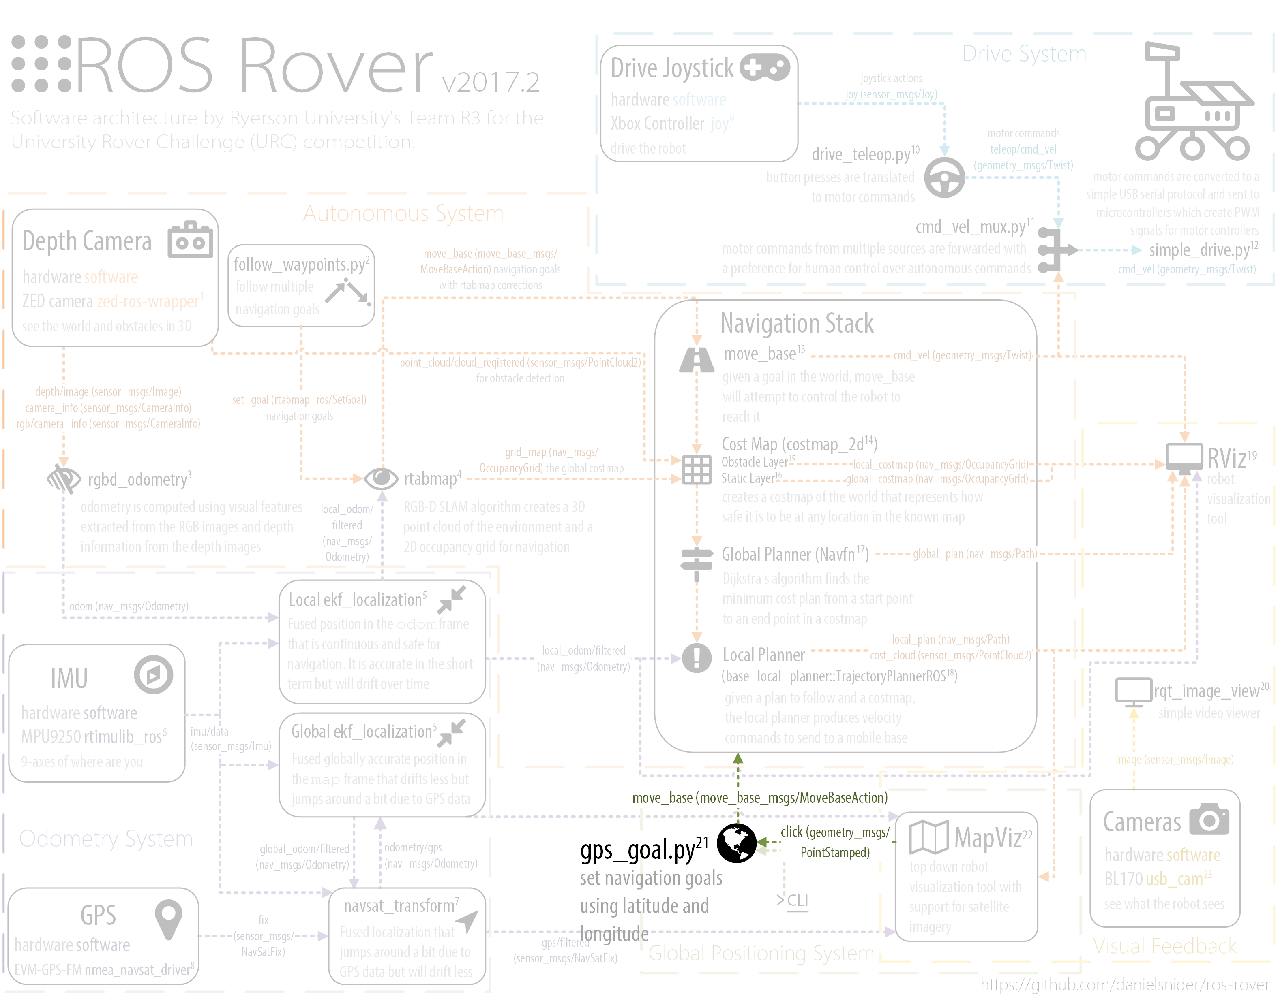

**Fig 22**  The GPS goal ROS node seen within Team R3’s rover system. See section 4.1 for the full diagram.

The new gps_goal package uses the WGS84 ellipsoid[20] and [geographiclib](https://geographiclib.sourceforge.io/)[21] python library for calculations.

The GPS goal can be set using a [geometry_msgs/PoseStamped](http://docs.ros.org/api/geometry_msgs/html/msg/PoseStamped.html) or [sensor_msgs/NavSatFix](http://docs.ros.org/api/sensor_msgs/html/msg/NavSatFix.html) message. The robot's desired yaw, pitch, and roll can be set in a PoseStamped message but when using a NavSatFix they will always be set to 0 degrees.

The goal is calculated in a ROS coordinate frame by comparing the goal GPS location to a known GPS location at the origin (0,0) of a ROS frame given by the local_xy_frame parameter (typically world). This initial origin GPS location is best published using a helper initialize_origin node (see the [initialize_origin](http://wiki.ros.org/gps_goal#initialize_origin) section below).

### Usage Instructions

1. Install the ROS package:

$ sudo apt-get install ros-kinetic-gps-goal

2. Launch the ROS node:

$ roslaunch gps_goal gps_goal.launch

3. Initialize known starting GPS location:

This is needed to calculate the distance to the goal.

# use the next GPS coordinate (requires package ros-kinetic-swri-transform-util)

$ roslaunch gps_goal initialize_origin.launch origin:=auto

OR

$ rostopic pub /local_xy_origin geometry_msgs/PoseStamped '{ header: { frame_id: "/map" }, pose: { position: { x: 43.658, y: -79.379 } } }' -1

4. Set a navigation goal using GPS coordinates (multiple styles are shown):

$ rostopic pub /gps_goal_fix sensor_msgs/NavSatFix "{latitude: 38.42, longitude: -110.79}" -1

OR

$ rostopic pub /gps_goal_pose geometry_msgs/PoseStamped '{ header: { frame_id: "/map" }, pose: { position: { x: 43.658, y: -79.379 } } }' -1

OR

$ roscd gps_goal

$ ./src/gps_goal/gps_goal.py --lat 43.658 --long -79.379 # decimal format

OR

$ ./src/gps_goal/gps_goal.py --lat 43,39,31 --long -79,22,45 # DMS format

### Command Line Interface (CLI)

You can invoke the gps_goal script once using the Command Line Interface (CLI).

$ roscd gps_goal

$ ./src/gps_goal/gps_goal.py --help

Usage: gps_goal.py [OPTIONS]

Send goal to move_base given latitude and longitude

Two usage formats:

gps_goal.py --lat 43.658 --long -79.379 # decimal format

gps_goal.py --lat 43,39,31 --long -79,22,45 # DMS format

Options:

--lat TEXT Latitude

--long TEXT Longitude

-r, --roll FLOAT Set target roll for goal

-p, --pitch FLOAT Set target pitch for goal

-y, --yaw FLOAT Set target yaw for goal

--help Show this message and exit.

Here we see the help command for the gps_goal script showing example usage styles for degree, minute, and seconds (DMS) or decimal GPS formats. Using command line arguments users can also set the desired roll, pitch, and yaw final position.

gps_goal ROS Node

### Actions Called

move_base ([move_base_msgs/MoveBaseAction](http://wiki.ros.org/move_base_msgs/MoveBaseAction))

The move_base action server performs navigation to the goal.

### Subscribed Topics

gps_goal_pose ([geometry_msgs/PoseStamped](http://docs.ros.org/api/geometry_msgs/html/msg/PoseStamped.html))

Set a GPS goal using a PoseStamped message. The x and y values will be considered latitude and longitude respectively. Z, roll, pitch, and yaw values will be respected.

gps_goal_fix ([sensor_msgs/NavSatFix](http://docs.ros.org/api/sensor_msgs/html/msg/NavSatFix.html))

Set a GPS goal using a NavSatFix GPS message. The goal for roll, pitch, and yaw will be 0 degrees because they are not in this message type.

local_xy_origin ([geometry_msgs/PoseStamped](http://docs.ros.org/api/geometry_msgs/html/msg/PoseStamped.html))

The topic to get the origin GPS location from. This location is the origin (0,0) of the frame (typically world) given by the local_xy_frame parameter to the initialize_origin node. This location is used to calculate distances for goals. One message on this topic is consumed when the node starts only.

### Parameters

~frame_id (string, default: map)

The [tf](http://wiki.ros.org/tf) frame for move_base goals.

### initialize_origin ROS Node

The initialize_origin node will continuously publish (actually in a latched[22] manner) a [geometry_msgs/PoseStamped](http://docs.ros.org/api/geometry_msgs/html/msg/PoseStamped.html) on the local_xy_origin topic and this is better than manually publishing the origin GPS location with rostopic pub. This location is the origin (0,0) of the frame (typically world) given by the local_xy_frame parameter to the initialize_origin node. This location is used to calculate distances for goals. One message on this topic is consumed when the node starts only.

This node is provided by the [swri_transform_util](http://wiki.ros.org/swri_transform_util) package (apt-get install ros-kinetic-swri-transform-util) and it is often launched as a helper node for [MapViz](http://wiki.ros.org/mapviz), a top-down robot and world visualization tool. There are two modes for initialize_origin: static or auto.

**Static Mode**

You can hard code a GPS location (useful for testing) for the origin (0,0). In the following example the coordinates for the Mars Desert Research Station (MDRS) are hard coded in initialize_origin.launch and selected on the command line with the option "origin:=MRDS".

$ roslaunch gps_goal initialize_origin.launch origin:=MRDS

**Auto Mode**

When using the "auto" mode, the origin will be to the first GPS fix that it receives on the topic configured in the initialize_origin.launch file.

$ roslaunch gps_goal initialize_origin.launch origin:=auto

**Launch example**:

<node pkg="swri_transform_util" type="initialize_origin.py" name="initialize_origin" output="screen">

<param name="local_xy_frame" value="/world"/>

<param name="local_xy_origin" value="MDRS"/> <!-- setting "auto" here will set the origin to the first GPS fix that it recieves -->

<remap from="gps" to="gps"/>

<rosparam param="local_xy_origins">

[{ name: MDRS,

latitude: 38.40630,

longitude: -110.79201,

altitude: 0.0,

heading: 0.0}]

</rosparam>

</node>

### Normal Output

When you launch and use the gps_goal ROS node or CLI interface you will see the following console output.

$ roscd gps_goal

$ ./src/gps_goal/gps_goal.py --lat 43.658 --long -79.379

[INFO]: Connecting to move_base...

[INFO]: Connected.

[INFO]: Waiting for a message to initialize the origin GPS location...

[INFO]: Received origin: lat 43.642, long -79.380.

[INFO]: Given GPS goal: lat 43.658, long -79.379.

[INFO]: The distance from the origin to the goal is 97.3 m.

[INFO]: The azimuth from the origin to the goal is 169.513 degrees.

[INFO]: The translation from the origin to the goal is (x,y) 91.3, 13.6 m.

[INFO]: Executing move_base goal to position (x,y) 91.3, 13.6, with 138.14 degrees yaw.

[INFO]: To cancel the goal: 'rostopic pub -1 /move_base/cancel actionlib_msgs/GoalID -- {}'

[INFO]: Inital goal status: PENDING

[INFO]: Final goal status: COMPLETE

## Tutorial: Wireless Communication

**2.4 GHz, 433 MHz, and a Unity simulation for blind driving the rover**

Source code: <https://github.com/itu-rover/communication>

At Team ITU, communication was one of the things we were most afraid of having problems with so we really spent a good amount of time on this. In our earlier development time we were using Bullet M2s as our main link but after failing non-line of sight tests at long distances (400-500 meters) we searched a little bit more and found the Microhard pDDL2450, a 2.4 GHz radio, from a sponsor’s advice. Luckily they had a few spares and donated them to the team. Those were able to communicate at 1km, non-line of sight with standard 8 dBi omnidirectional antennas at both the ground station and rover.

As a backup to the main wireless Ethernet link, our second link was a lower radio frequency (RF) link in the UHF band. The RF device used in the both ends were 433 MHz LoRa modules[23]. The LoRa modules were wired to the standard RX-TX wires on our STM32F103 (similar to XBee wiring[24]) and uses UART communication. To make the RF link active, we just start communication with the LoRa in C# with:

SerialPort _serialPort = new SerialPort("COM1", 115200, Parity.None, 8, StopBits.One);

_serialPort.Open();.

Then, we start receiving and transmitting data with: _serialPort.ReadLine() and _serialPort.WriteLine() respectively.

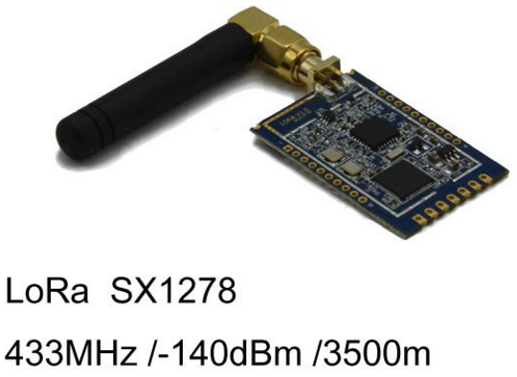

**Fig. 16**  UHF LoRa radio module for long range communication.

For the autonomous mission we operated using the RF link because the rover would get very far away from the ground station and in a non-line of sight (NLOS) condition, so it seemed more logical to use it. We send the target coordinates to the low level system via RF link and then the low level system gives the coordinates to the Raspberry Pi and this is where ROS comes in to move the rover.

The wireless Ethernet link was connected to the Raspberry Pi and if wireless were to go down or we detect a problem with the Raspberry Pi, we would tell our software to close the Ethernet link and open the RF link. We had very good results and our communication link never went down during the competition.

**Unity simulation for driving robot without camera feed**

When in RF mode, using only GPS coordinates of the vehicle, we were able to drive the rover without any video stream. Using TerraUnity, we simulated the competition environment one-to-one. So the driver could just look at the ground station monitor and see the terrain around the vehicle in the Unity graphics simulation, which was pretty precise in our tests. This provided us a chance to blind drive the vehicle without the video feed. We never had to use it during the competition but it was working in our tests.

Lastly, we had a third backup system that took over if we lost all communications (RF and Ethernet together) the rover would navigate autonomously to the last point that any signal was received.

## Tutorial: Autonomous Navigation by Team ITU

In 2017, the URC competition added an autonomous driving task. We have written about the rules of this task in section 2.1.1 Autonomous Task of this chapter. In this tutorial Team ITU describes their approach to the challenge of autonomously diving to given approximate GPS coordinate and then finding and parking beside the tennis ball goal post. This autonomous task has increasing levels of distances and difficulties.

**Twist_mux, move_base and finding tennis balls**

Firstly, Team ITU uses the twist_mux[25] ROS package to support simultaneous teleoperation and autonomous driving for the following reason, “When there are more than a single source to move a robot with a Twist message, it is important to multiplex all those input sources into a single one that goes to the motor controller (e.g. diff_drive_controller)”. The twist_mux ROS package is even better for this than the cmd_vel_mux[26] ROS node included in the simple_drive package.

Team ITU uses twist_mux with a configuration_file (team ITU’s config[27]) to combine the following three input velocities used to move the vehicle:

1. joy_vel: Velocity from joystick commands. Priority: 100

2. cmd_vel: Velocity from the autonomous system (move_base) to achieve the desired position. Priority: 10

3. final_vel: The velocity calculated to reach the tennis ball objective after finding it. Priority: 10

The cmd_vel and final_vel priorities are equal because we didn't want them to block each other as they should work together. In the competition, after reaching within 3 meters of the tennis ball objective’s GPS coordinates, cmd_vel becomes 0 and accepts that it reached the objective. Then the system looks for the final_vel and if it's 0 as well the system confirms that it has reached the objective, then we talk with the judges to confirm we have reached our waypoint.

The final_vel topic, which is published by our test_tennis_ball.cpp[28] node which determines where the ball is and turns the vehicle towards the ball and goes forward until the ball is big enough, which means we are close enough to the ball.

The twist_mux node sends velocities to our rover_velocity_controller.py[29] node on husky_velocity_controller/cmd_vel and then by serial_com.py[30] to our low level system. The low level system (STM32F103) is written such that it just takes the velocity from ROS and navigates accordingly. The message we send to the low level from USB interface is constructed as B(Begin) - 0 or 1(0 for backward 1 for forward) - 00 to 99(linear velocity) - 0 or 1(left or right) - 00 to 99(angular velocity) - E(End). So a sample message would be "B152039E". Which means go forward with %52 of the full speed and go left with %39 of the full speed.

## Tutorial: Autonomous Navigation by Team R3

To give another example of an autonomous driving system, this time with a stereo camera, SLAM and obstacle avoidance, we present Team R3’s design. For a description of the requirements of the autonomous task for URC 2017, please see section 2.1.1 Autonomous Task of this chapter.

Fig 17. depicts the ROS software architecture in Team R3’s autonomous system. For a larger diagram with more components and explanation see section 4.1. This diagram is also available in Visio format[31]

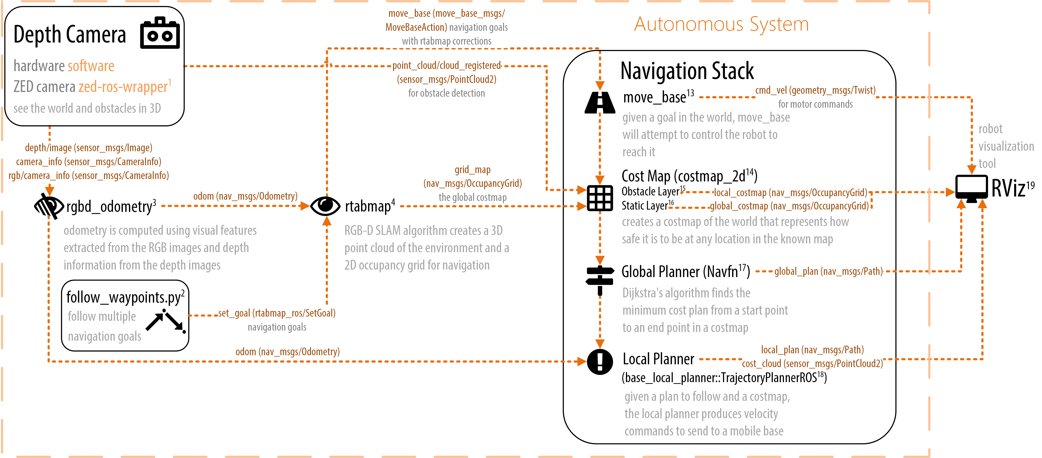**ZED depth camera, RTAB-Map, and move_base**

**Fig. 17** Team R3’s autonomous navigation system used at URC 2017 rover competition.

ZED Depth Camera

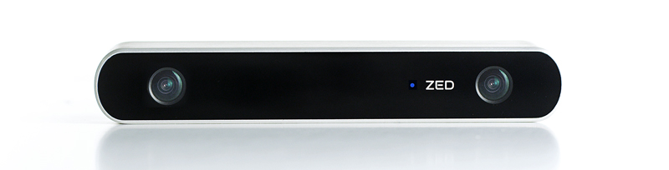

**Fig. 18**  The ZED depth camera.

The ZED stereo camera[32][33] and ROS wrapper software perform excellently for the price of $450. It was key to us getting obstacle avoidance working and even SLAM loop closures working. However we could not do this and move the rover faster than a slow-moderate human walking speed because the performance of our Nvidia Jetson TX1 was maxing out. It is important to know that a restriction of the ZED camera is that it requires an Nvidia GPU, a dual-core processor, and 4GB of RAM. All of which the Nvidia Jetson TX1 has[34].

The ZED camera combined with RTAB-Map for SLAM localization and mapping worked reasonably robustly even in Utah’s desert where the ground’s feature complexity is low and even with a significant amount of shaking on the pole which our ZED camera was attached to.

Here is a tip when using the ZED camera, launch the node with arguments so you can more easily find the right balance between performance and resolution. At URC we wanted the lowest latency so we default to VGA resolution, at 10 FPS, and low depth map quality. The ZED camera designed for outdoor textured surfaces. Indoors you might want to attach a blinder on top of the camera so that it doesn’t see the ceiling as an obstacle.

$ roslaunch rover zed_up frame_rate:=30 resolution:=2 depth_quality:=3

<launch>

<arg name="frame_rate" default="10" />

<arg name="resolution" default="3" />

<arg name="depth_quality" default="1" />

<node output="screen" pkg="zed_wrapper" name="zed_node" type="zed_wrapper_node">

<param name="frame_rate" value="$(arg frame_rate)"/>

<!-- Image resolution options: -->

<!-- ‘0’: HD2K, ‘1’: HD1080, ‘2’: HD720, ‘3’: VGA -->

<param name="resolution" value="$(arg resolution)"/>

<!-- Depth map quality options: -->

<!-- ‘0’: NONE, ‘1’: PERFORMANCE, ‘2’: MEDIUM, ‘3’: QUALITY -->

<param name="quality" value="$(arg depth_quality)"/>

</node>

<node pkg="image_transport" type="republish" name="zed_camera_feed" args="raw in:=rgb/image_rect_color out:=rgb_republished" />

</launch

Full zed launch file example: <https://github.com/teamr3/URC/blob/master/rosws/src/rover/launch/zed_up.launch>

**Reduce Bandwidth Used by Video Streams**

To lower the amount of data on our wireless link, on line 14 we publish the ZED camera as JPEG compressed stills and Theora video streaming using the republish[35] node of the image_transport ROS package. republish listens on one uncompressed (raw) image topic and republishes JPEG compressed stills and Theora video on different topics.

To lower bandwidth even further you can convert images to greyscale, cutting data usage by 3. Team R3 has a small ROS node for this[36].

Additionally, you should use the republish node when more than one ROS node is subscribing to a depth or image stream over a wireless connection. Instead you should have one republish node subscribe at the base station, then multiple ROS nodes at the base station can subscribe to the republish node without consuming a lot of wireless bandwidth. This is also referred to as a ROS relay.

### Visual Odometry with rgbd_odometry

The ZED camera does not have a gyroscope or accelerometer in it. It uses visual information for odometry and it is quite good. We found that the rgbd_odometry[37] node provided by the rtabmap package produces better visual odometry than the standard ZED camera odometry algorithm. Visual odometry was very robust to jitter and shaking as the rover moved over rough terrain, even with our camera on a tall pole which made the shaking extreme.

In the comments of the launch file below we show some tips that we used at URC 2017.

<launch>

<node output="screen" type="rgbd_odometry" name="zed_odom" pkg="rtabmap_ros">

**<!-- 2D SLAM makes the position drift less over time -->**

<param name="Reg/Force3DoF" type="string" value="true"/>

**<!-- Change if camera is tilted downwards or any non-level pose -->**

<param name="initial_pose" value="0 0 0 0 0 0"/>

**<!-- Options to Reduce Resource Usage -->**

<!-- 0=Frame-to-Map (F2M) 1=Frame-to-Frame (F2F) -->

<param name="Odom/Strategy" value="1"/>

<!-- Correspondences: 0=Features Matching, 1=Optical Flow -->

<param name="Vis/CorType" value="1"/>

<!-- maximum features map size, default 2000 -->

<param name="OdomF2M/MaxSize" type="string" value="1000"/>

<!-- maximum features extracted by image, default 1000 -->

<param name="Vis/MaxFeatures" type="string" value="600"/>

</node>

</launch>

Full rgbd_odometry launch file example: <https://github.com/teamr3/URC/blob/master/rosws/src/rover_navigation/launch/rgbd_odometry.launch>

### RTAB-Map

Using depth data, RTAB-Map[38][39] creates a continuously growing point cloud of the world using SLAM[40]. Inherent to the SLAM algorithm is pin pointing your own location in the map that you are building as you move. Using this map, RTAB-Map then creates an occupancy grid, which represents free and occupied space, needed to avoid obstacles in the rover’s way. RTAB-Map’s algorithm has real-time constraints so that when mapping large-scale environments time limits are respected and performance does not degrade[41].

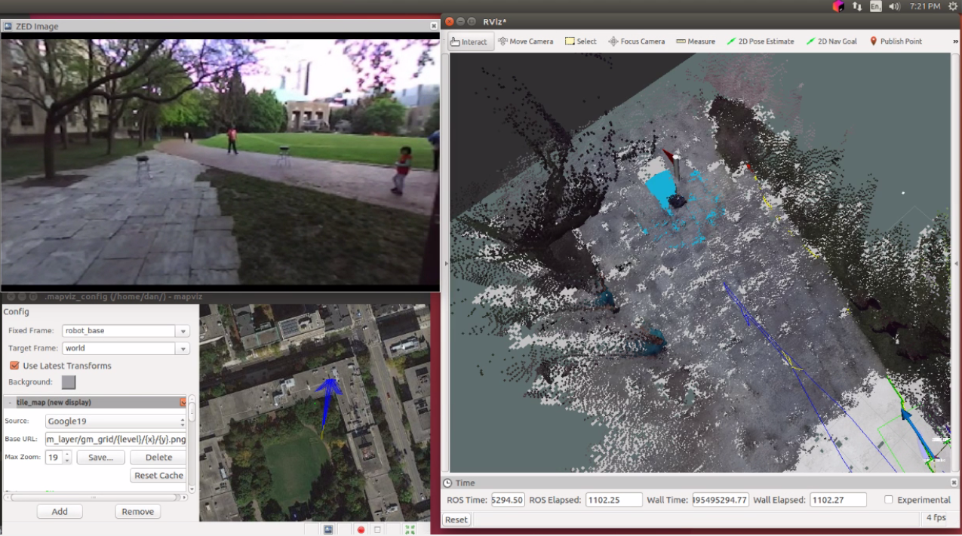

**Fig. 19** Screenshot of R3’s autonomous system tests with RTAB-Map (video available on YouTube[42]).

In the launch file below on lines 3-8, we share tips for reducing noisy detection of obstacles. If you set MaxGroundAngle to 180 degrees, this effectively disables obstacle detection, which can be both useful and dangerous.

RTAB-Map must also perform loop closures. Loop closure is the problem of recognizing a previously-visited location and updates the beliefs accordingly[43]. When an image is matched to a previously-visited location, a loop closure is said to have occurred. At this point RTAP-Map will adjust the map to compensate for drift that occurred since the last time the location was visited. On lines 10-18 we give some tips for increasing the chances of loop closures being detected.

<launch>

<node pkg="rtabmap_ros" name="rtabmap" type="rtabmap" output="screen">

**<!-- Improve obstacle detection -->**

<param name="Grid/MaxGroundAngle" value="110"/> <!-- Maximum angle between point's normal to ground's normal to label it as ground. Points with higher angle difference are considered as obstacles. Default: 45 -->

<param name="grid_eroded" value="true"/> <!-- remove obstacles which touch 3 or more empty cells -->

**<!-- Improve loop closure chances -->**

<param name="RGBD/LoopClosureReextractFeatures" type="string" value="true"/> <!-- Extract features even if there are some already in the nodes, more loop closures will be accepted. Defalut: false -->

<param name="Vis/MinInliers" type="string" value="10"/> <!-- Minimum feature correspondences to compute/accept the transformation. Default: 20 -->

<param name="Vis/InlierDistance" type="string" value="0.15"/> <!-- Maximum distance for feature correspondences. Used by 3D->3D estimation approach (the default approach). Default: 0.1 -->

</node>

</launch>

Full rtabmap launch file example: <https://github.com/teamr3/URC/blob/master/rosws/src/rover_navigation/launch/rtabmap.launch>

Team R3’s main strategy for the autonomous task of URC 2017 was to:

1. Build a SLAM map by teleoperating from the start gate all the way to the tennis ball objective (actually this could be an autonomous navigation attempt by using the GPS location of the tennis ball as the goal),
2. then we would then put a flag[44] in RViz to mark where we observed the tennis ball,
3. and then we would teleoperate back to the start gate,
4. and complete a loop closure to correct for drift,
5. and then use RViz to set an autonomous goal for where we saw the tennis ball.

### move_base Path Planning

The ROS navigation stack[45], also known as move_base[46], is a collection of components/plugins that are selected and configured by yaml configuration files.

<launch>

<node pkg="move_base" type="move_base" name="move_base" output="screen" clear_params="true">

<rosparam file="$(find rover)/costmap_common_params.yaml" command="load" ns="global_costmap"/>

<rosparam file="$(find rover)/costmap_common_params.yaml" command="load" ns="local_costmap"/>

<rosparam file="$(find rover)/local_costmap_params.yaml" command="load"/>

<rosparam file="$(find rover)/global_costmap_params.yaml" command="load"/>

<rosparam file="$(find rover)/base_local_planner_params.yaml" command="load"/>

</node>

</launch>

Full move_base launch file example: <https://github.com/teamr3/URC/blob/master/rosws/src/rover_navigation/launch/move_base.launch>

The most interesting configuration file for move_base is the base_local_planner_params.yaml. Given a path for the robot to follow and a costmap, the base_local_planner[47] produces velocity commands to send to a mobile base. This configuration is where you set minimum and maximum velocities and accelerations for your robot, as well as goal tolerance.

TrajectoryPlannerROS:

acc_lim_x: 0.5

acc_lim_y: 0.5

acc_lim_theta: 1.00

max_vel_x: 0.27

min_vel_x: 0.20

max_rotational_vel: 0.4

min_in_place_vel_theta: 0.27

max_vel_theta: 0.1

min_vel_theta: -0.1

escape_vel: -0.19

holonomic_robot: false

xy_goal_tolerance: 1

yaw_goal_tolerance: 1.39626 # 80 degrees

# make sure that the minimum velocity multiplied by the sim_period is less than twice the tolerance on a goal. Otherwise, the robot will prefer to rotate in place just outside of range of its target position rather than moving towards the goal.

sim_time: 1.7 # set between 1 and 2. The higher he value, the smoother the path (though more samples would be required)

Full configuration file: <https://github.com/teamr3/URC/blob/master/rosws/src/rover_navigation/config/base_local_planner_params.yaml>

## Tutorial: MapViz Robot Visualization Tool

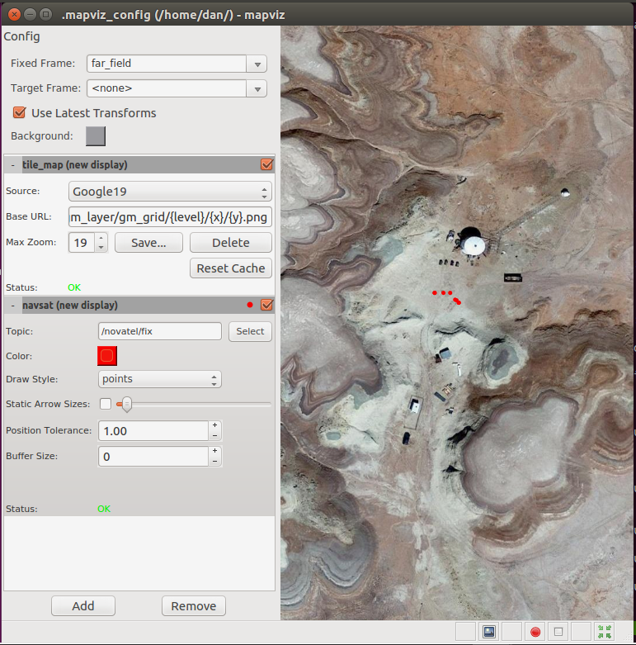 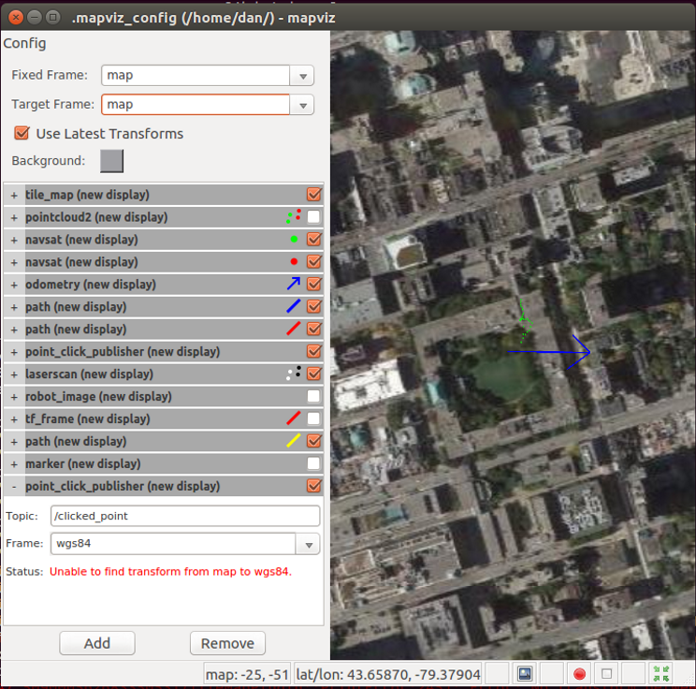

**Fig. 20**  Screenshots of MapViz ROS visualization tool. Red and green dots indicate gps coordinates.

Improve your situational awareness by using MapViz. Mapviz is a ROS-based visualization tool with a plug-in system similar to rviz focused on visualization 2D data[48]. Created by the Southwest Research Institute in Florida for their outdoor autonomous robotics research, it is still under active open source development at the time of writing in December 2017. Using a plugin called tile-map, Google Maps satellite view can be viewed in MapViz Tile Map plugin.

The authors have contributed a Docker container to make displaying Google Maps in MapViz as easy as possible[49]. This container run software called MapProxy and which converts from the format of Google Maps API to a standard format called Web Map Tile Service (WMTS) which MapViz Tile Map plugin can display. The authors have also configured[50] MapProxy to cache any maps that you load to ~/mapproxy/cache_data so that they are available offline.

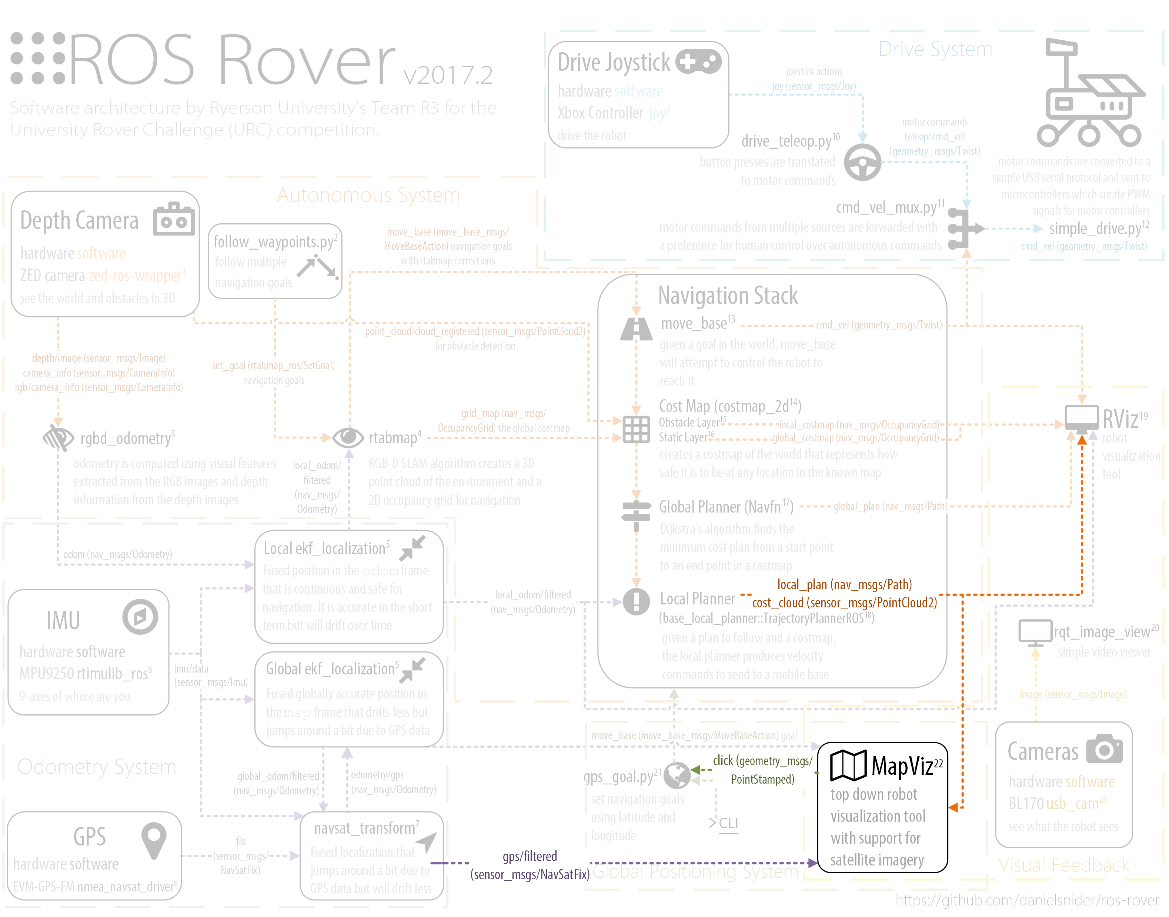

**Fig. 21**  MapViz ROS node seen within Team R3’s rover system. See section 4.1 for the full diagram.

### Quick Start

The goal of this tutorial is to install and configure MapViz to display Google Maps.

1. Install mapviz, the plugin extension software, and the plugin for supporting tile maps which is needed to display Google Maps:

$ sudo apt-get install ros-kinetic-mapviz ros-kinetic-mapviz-plugins ros-kinetic-tile-map

2. Launch the MapViz GUI application:

$ roslaunch mapviz mapviz.launch

3. Using Docker to setup a proxy of the Google Maps API so that it can be cached and received by MapViz in WMTS format. To make this as simple as possible, run the Docker container created by the authors:

$ sudo docker run -p 8080:8080 -d -t -v ~/mapproxy:/mapproxy danielsnider/mapproxy

The –v ~/mapproxy:/mapproxy option is a shared volume, a folder that it synced between the Docker container and the host computer. The ~/mapproxy folder needs to be created, though it could be another location. The –t option allocates a pseudo-tty which gives the program a terminal environment to run in. It is needed for most programs. The –p option sets the Docker port mapping between host and container.

4. Confirm MapProxy is working by browsing to <http://127.0.0.1:8080/demo/>. The MapProxy logo will be displayed and click on "Image-format png" to get an interactive map. Also, test that the first map tile is working by browsing to <http://localhost:8080/wmts/gm_layer/gm_grid/0/0/0.png>.

5. In the MapViz GUI, click the "Add" button and add a new map_tile display component.

6. In the "Source" dropdown select "Custom WMTS Source...".

7. In the "Base URL:" field enter the following:

http://localhost:8080/wmts/gm_layer/gm_grid/{level}/{x}/{y}.png

8. In the "Max Zoom:" field enter 19 and Click "Save...". This will permit MapViz to zoom in on the map 19 times.

Google Maps will now display in MapViz. To set a default location in the world to display at program start up time, you can edit ~/.mapviz_config.

$ vim ~/.mapviz_config

# edit the following

offset_x: 1181506

offset_y: -992564.2

## Tutorial: Effective Robot Administration

In this tutorial, Team R3 shares two favorite preferences for making command line administration of ROS robots easier both for the URC competition and any other use case.

### tmux Terminal Multiplexer

Tmux[51] is a popular linux command line program that can take over one terminal window and organize many terminals into grouped layouts and will continue running when you close the parent window or lose an SSH connection. Multiple people can join a tmux session to share an identical terminal view of a Linux system. Many technology professionals see tmux as essential to their work[52].

Tmux’s organization works harmoniously with ROS’s modular design. Separate tmux windows can display different ROS components. Almost any ROS component can be launched, controlled, and debugged using ROS’s command line tools. Using tmuxinator[53], you can codify the launching and debugging commands that you most often use into a repeatable layout.

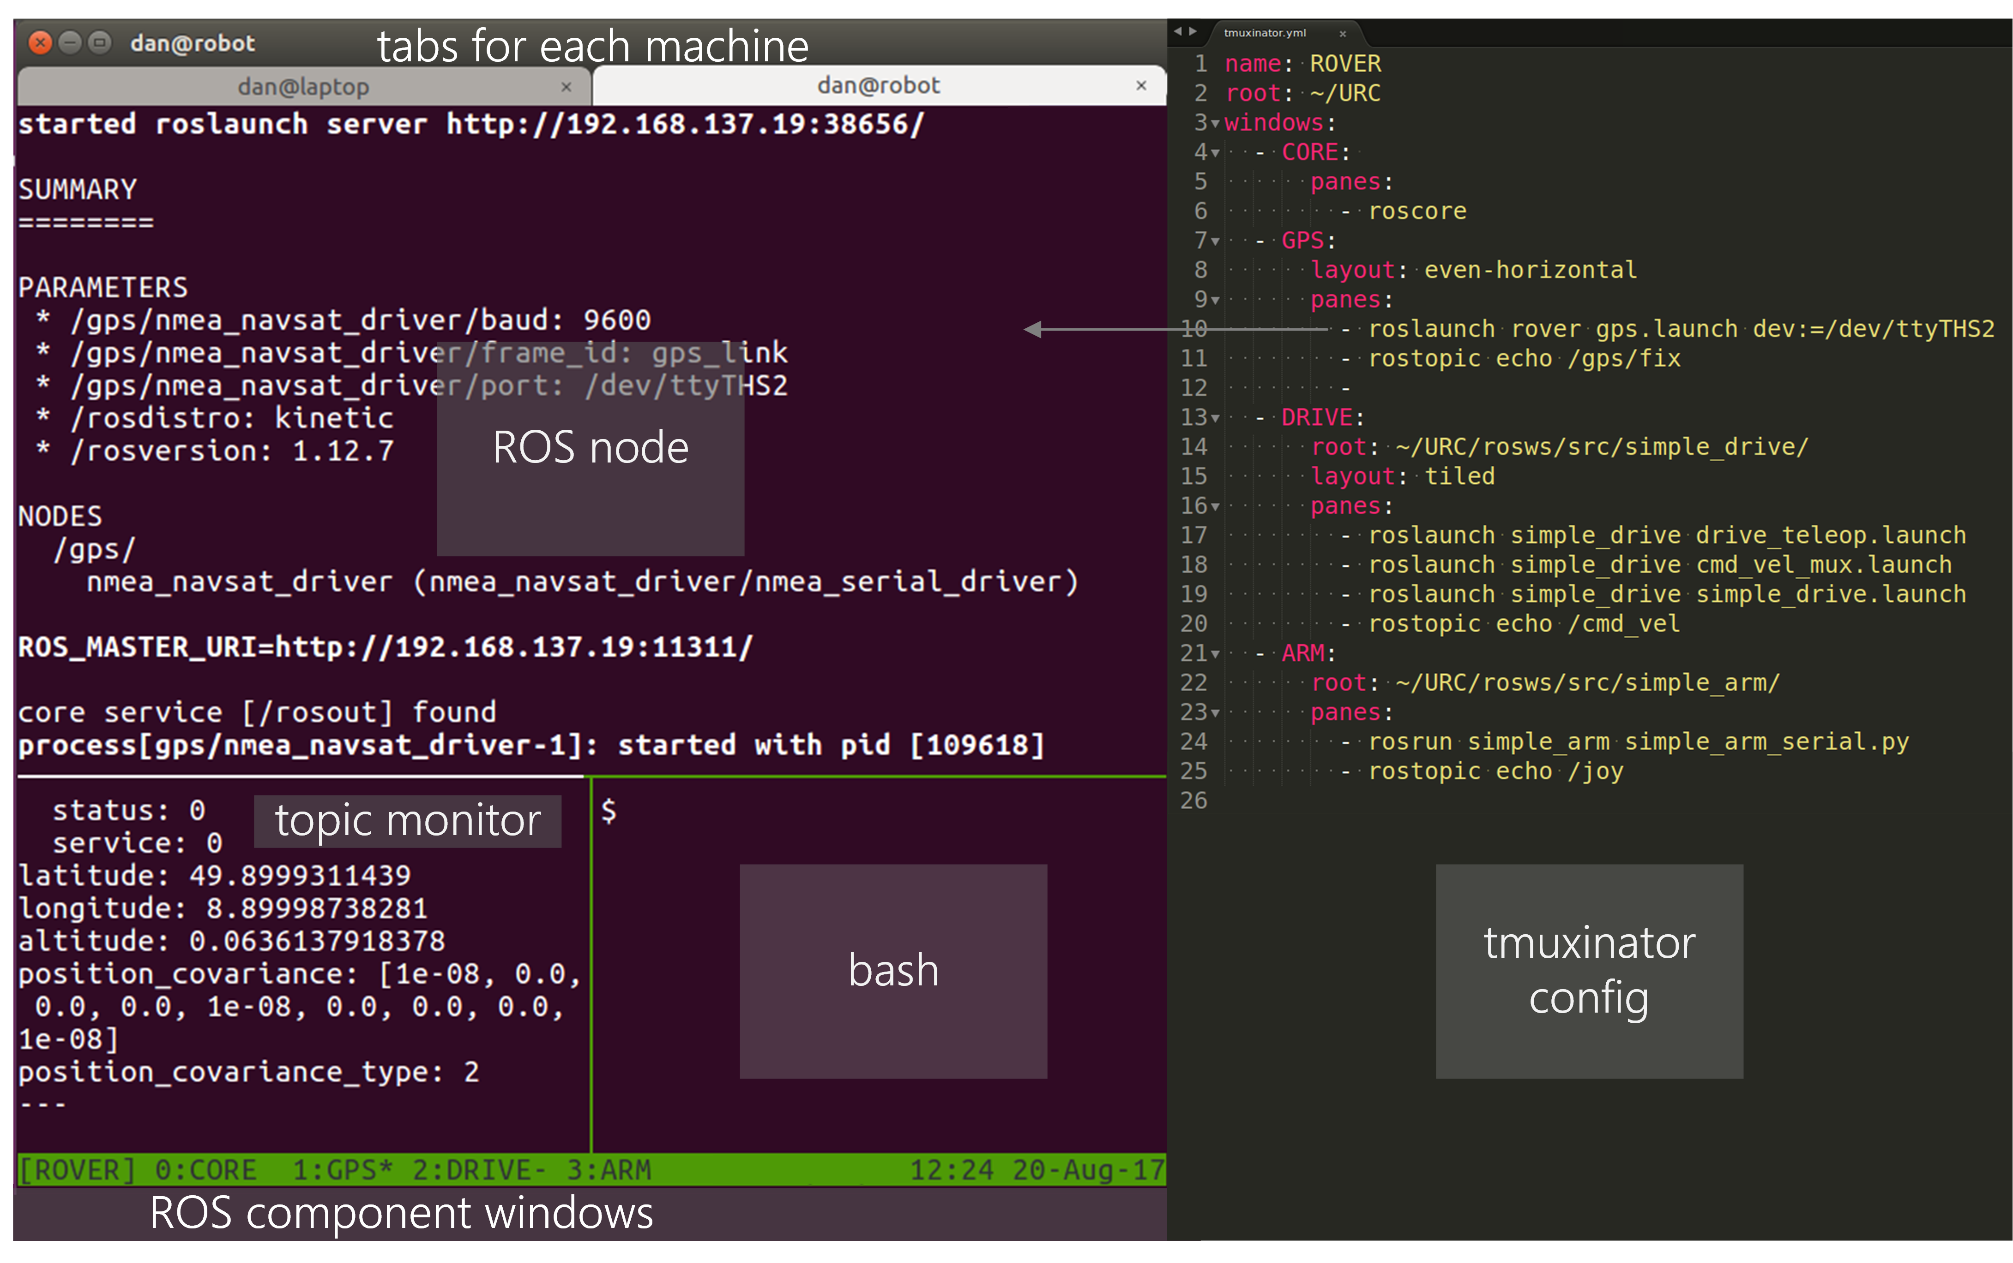

Fig. 23 An annotated example of tmuxinator’s usefulness for ROS.

Using Tmuxinator is a quick way to create a very simple user interface to help administer a robot (but it is not a replacement for Rviz and other existing tools). Building a robot GUI as a web interface or desktop application can be useful for some applications and novices who are unwilling to learn common command line tools, but such a GUI will require a lot more “plumbing” and “glue code” to create.

Because tmuxinator starts all of its panes at the same time, running multiple roslaunch instances may try and fail to create multiple masters. The solution we implemented was to run a roscore separately, which has the added benefit of being able to stop and start roslaunches without worrying about which one is running the master. This still has the problem of roslaunches starting before the roscore though, so to solve this naively we have used a small wait time, for example “sleep 3; roslaunch...” in our tmuxinator config.

The tmuxinator configuration used by Team R3 was split into two sides: the robot config[54], and the base station config[55]. The robot configuration launches all of the robot’s software. The base station configuration launches all of the software needed to visualize and control the robot.

### ROS Master Helper Script

Team R3 has developed a script[56] to automatically set your ROS_IP environment variable and to detect an online robot using ping and set your ROS_MASTER_URI environment variable (assumes a static IP for your robot). If your robot is not online your own ROS_IP will be used in your ROS_MASTER_URI. To use this script run 'source ~/set_robot_as_ROS_master.sh' or add to you '.bashrc'.

# Conclusion

This chapter presented an overview of rover systems through the lense of the University Rover Competition. Design summaries of 8 URC teams were surveyed and implementation details from 3 URC teams were discussed in a series of tutorials. New ROS packages were documented with examples, installation and usage instructions along with implementation details.

To summarize the main findings in this chapter: Rovers can be built by integrating existing software as we illustrate and thanks to the ROS ecosystem. The URC competition is very challenging and students learned a lot by participating. A variety of creative rover designs exist and the best rover teams were the most prepared and practiced.

We hope this chapter spurs greater collaboration between teams. Ideally, the teams of URC will look past the competitive nature of the event and view collaborating and building better robotsas the more important goal. Building on a common core frees up time to focus on the hardest parts. Here are a few ways to further collaboration: 1) Contribute to a ROS package or the ROS core. 2) Open an issue, feature request, or pull request. 3) Discuss URC on the URC Hub forum[57]. 4) Discuss ROS on their forums[58]. 5) Contribute to a book like this.

**Acknowledgments** We thank our advisor Professor Michael R. M. Jenkin P.Eng., Electrical Engineering and Computer Science, York University, NSERC Canadian Field Robotics Network. We also thank and appreciate the contributions of our survey respondents: Khalil Estell from San Jose State University, SJSU Robotics, and Jacob Glueck from Cornell University, Cornell Mars Rover, and Hunter D. Goldstein from Cornell University, Cornell Mars Rover, and Akshit Kumar from Indian Institute of Technology, Madras, Team Anveshak, and Jerry Li from University of Waterloo, UWRT, and Gabe Casciano from Ryerson University, Team R3, and Jonathan Boyson from Missouri University of Science and Technology (Missouri S&T), Mars Rover Design Team.

**References**

**Author Biographies**

**Daniel Snider**, received a bachelor of information technology (BIT) from the University of Ontario Institute of Technology in Ontario, Canada (2013). He is currently a member of the R3 robotics team at Ryerson University and works as a computer vision software developer at SickKids Research Institute which is associated with the University of Toronto. His current research is on the design of modular polygot frameworks (such as ROS) and scientific workflow systems.

**Matthew Mirvish**, Bloor Collegiate Institute, Hacklab.TO Toronto, Canada, Team R3

**Michał Barciś**, University of Wrocław, Poland, Team Continuum

**Vatan Aksoy Tezer**, Istanbul Technical University, Turkey, ITU Rover Team

1. URC 2017 Rules <http://tinyurl.com/urc-rules>
2. <http://urc.marssociety.org/home/urc-news/americanroverearnsworldstopmarsrovertitle>
3. URC 2017 Rules <http://tinyurl.com/urc-rules>
4. URC 2018 Rules <http://tinyurl.com/urc-rules2018>
5. ITU Rover Autonomous source code: <https://github.com/itu-rover/ros/tree/master/catkin_ws/src>
6. ITU Rover communication modules: <https://github.com/itu-rover/communication>
7. Continuum Inverse kinematics python source: <https://gist.github.com/danielsnider/5181ca50cef0ec8fdea5c11279a9fdbc>
8. A recent video of from the University of Wrocław of their rover has incredible cinematography: <https://www.youtube.com/watch?v=MF8DkKDBXtg>
9. <https://github.com/danielsnider/ros-rover/blob/master/diagrams/Rover_Diagram.vsdx?raw=true>
10. <http://wiki.ros.org/navigation>
11. <http://wiki.ros.org/rtabmap_ros/Tutorials/StereoOutdoorNavigation>
12. Clearpath Jackal tutorials for Ubuntu 14.04 <http://docs.ros.org/indigo/api/jackal_tutorials/html/simulation.html>
13. SMACH state machine library for python <http://wiki.ros.org/smach>
14. One alternative to SMACH is py-trees, a behavior tree library <http://py-trees.readthedocs.io/en/devel/background.html>
15. <https://github.com/danielsnider/ros-rover/blob/master/diagrams/simple_drive_Xbox_Controller.vsdx?raw=true>
16. [https://github.com/danielsnider/ros-rover/blob/master/diagrams/simple_arm_joystick_diagram.vsdx?raw=true](https://github.com/danielsnider/ros-rover/blob/master/diagrams/simple_arm_joystick_diagram.vsdx?raw=true%20)
17. Real time computing <https://en.wikipedia.org/wiki/Real-time_computing>
18. <http://hugin.sourceforge.net/>
19. <http://wiki.panotools.org/Panorama_scripting_in_a_nutshell>
20. <https://en.wikipedia.org/wiki/World_Geodetic_System#A_new_World_Geodetic_System:_WGS.C2.A084>
21. <https://geographiclib.sourceforge.io/>
22. When a connection is latched, the last message published is saved and automatically sent to any future subscribers that connect.
23. LoRa URF radio module <http://www.iotglobalnetwork.com/products/single/id/1187/wireless-technology-lora-433mhz-rf-module>
24. Wiring diagram <http://www.pyroelectro.com/tutorials/arduino_pic_communication/theory2.html>
25. The twist_mux ROS package <http://wiki.ros.org/twist_mux>
26. [http://wiki.ros.org/simple_drive#cmd_vel_mux](http://wiki.ros.org/simple_drive%23cmd_vel_mux)
27. <https://github.com/itu-rover/ros/blob/master/catkin_ws/src/rover_control/src/rover_twist_mux.yaml>
28. <https://github.com/itu-rover/ros/blob/master/catkin_ws/src/rover_vision/src/test_tennis_ball.cpp>
29. <https://github.com/itu-rover/ros/blob/master/catkin_ws/src/rover_control/src/rover_velocity_controller.py>
30. <https://github.com/itu-rover/ros/blob/master/catkin_ws/src/rover_control/src/serial_com.py>
31. <https://github.com/danielsnider/ros-rover/blob/master/diagrams/team_r3_AUTO_Diagram.vsdx?raw=true>
32. ZED stereo camera technical specs <https://www.stereolabs.com/zed/>
33. More ZED camera documentation <https://www.stereolabs.com/documentation/guides/using-zed-with-ros/ZED_node.html>
34. Nvidia Jetson TX1 technical specs <https://developer.nvidia.com/embedded/buy/jetson-tx1-devkit>
35. [http://wiki.ros.org/image_transport#republish](http://wiki.ros.org/image_transport%23republish)
36. <https://github.com/teamr3/URC/blob/master/rosws/src/rover/src/low_res_stream.py>
37. [http://wiki.ros.org/rtabmap_ros#rgbd_odometry](http://wiki.ros.org/rtabmap_ros%23rgbd_odometry)
38. RTAB-Map documentation <http://wiki.ros.org/rtabmap_ros>
39. RTAB-Map tutorials [http://wiki.ros.org/rtabmap_ros#Tutorials](http://wiki.ros.org/rtabmap_ros%23Tutorials)
40. Simultaneous localization and mapping (SLAM)
41. <https://introlab.github.io/rtabmap/>
42. Team R3’s autonomous navigation with rtabmap <https://www.youtube.com/watch?v=p_1nkSQS8HE>
43. [https://en.wikipedia.org/wiki/Simultaneous_localization_and_mapping#Loop_closure](https://en.wikipedia.org/wiki/Simultaneous_localization_and_mapping%23Loop_closure)
44. RViz flag tool <http://docs.ros.org/jade/api/rviz_plugin_tutorials/html/tool_plugin_tutorial.html>
45. <http://wiki.ros.org/navigation>
46. <http://wiki.ros.org/move_base>
47. <http://wiki.ros.org/base_local_planner>
48. <https://github.com/swri-robotics/mapviz>
49. <https://github.com/danielsnider/MapViz-Tile-Map-Google-Maps-Satellite>
50. <https://github.com/danielsnider/docker-mapproxy-googlemaps/blob/master/mapproxy.yaml>
51. <https://github.com/tmux/tmux/wiki>
52. <https://robots.thoughtbot.com/a-tmux-crash-course>
53. <https://github.com/tmuxinator/tmuxinator>
54. <https://github.com/teamr3/URC/blob/master/.tmuxinator.yml>
55. <https://github.com/teamr3/URC/blob/master/devstuff/dan/.tmuxinator.yml>
56. Team R3’s ROS master helper script <https://gist.github.com/danielsnider/13aa8c21e4fb12621b7d8ba59a762e75>
57. URC discussion forum <http://urchub.com/>
58. ROS discussion forum <https://discourse.ros.org/>